Christian Bartolé
2026
Abstract
This documentation is writing about the entire PIF project on how to recreate it step-by-step
PIf documentation
PIF (midterm 2)

Table of Contents
LAB 5
Raspberry PI installation & configuration 5
Installation 5
VNC viewer 9
Configure static IP: 14
Enable I²C interface: 15
Docker installation 17
Screen orientation 20
Disable on screen keyboard (optional) 24
Create folder /opt/station & /opt/station/www & copy files 24
Create a docker container 25
Configure autostart 26
Create folder /tmp/station 29
Redirect sensor readings to result.csv 29
MySQL setup 30
Mysql Database 30
Conceptual data model 33
Logical data model 33
Webserver 34
Notes: 34
Apache installation 34
MariaDB installation 34
PHP installation 34
phpMyAdmin installation 34
phpMyAdmin configuration 35
Install openssl and create self-signed SSL certificate 37
Redirect HTTP traffic to HTTPS 42
Data transfer 43
Config.toml 43
Receiver php script 43
Autostart configuration 46
Measurements file 47
Backup server 53
Allow external MySQL database access & restricted account 53
Create a new virtual machine 53
Export database setup 55
Crontab 56
Workshop 57
PVC plates assembly 57
Display plate 57
The base plate: 60
Plate assembly 61
PCB assembly 64
PVC plates assembly 68
Cable repair 73
Starting note: 73
Uninsulate wires 73
Wire stripping 75
Connect each wire back together 76
Cable insulation 77
Shielding tips 77
Sensors 1 78
Gas sensor 78
Bit I2C converter 79
Sensors 2 80
Biometric sensor 80
Gyroscope sensor 81
Sensor programming (BME280 / HW-611) 82
Sensor programming (BH1750) 84
Sources (for sprint Sensors 2): 86
Assembly 87
Material 87
Assembly (wooden box) 88
Assembly (button) 92
LED strip 97
Preparing LED strip 97
Putting the LED strip in place 99
Wire the LED strip to the board 100

LAB

Raspberry PI installation & configuration

Installation
After downloading, installing and executing the RasperryPI imager you need to select the correct model of the rasperry (Raspberry PI 4 Model 8 in this case), selecting the default & recommended Raspberry PI OS (64-BIT) & choose the correct drive (micro sd card in this case)

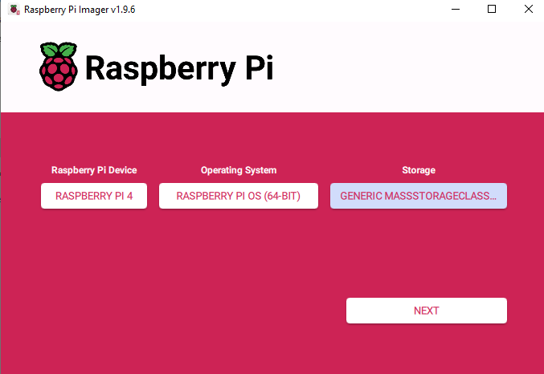

For the config of the raspberry you need to set a hostname which was in my case “PI<iam_code>” (“PI” was added by myself to mainly differentiate that it is a raspberrypi).
Configure a username & password, a network
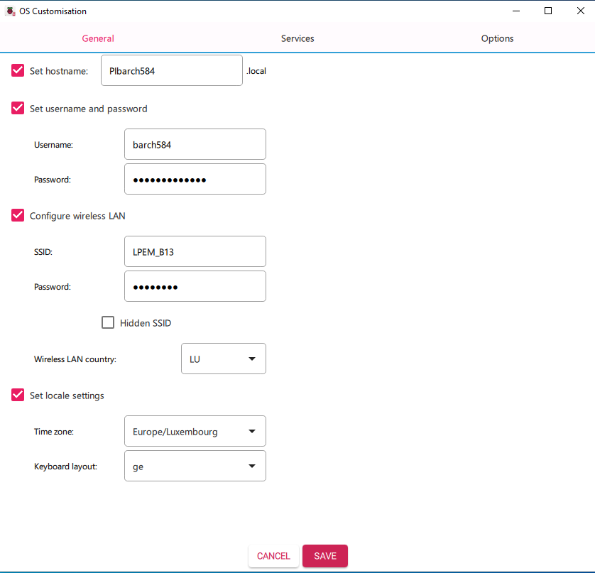
In the services tab enable SSH & select Use password authentication
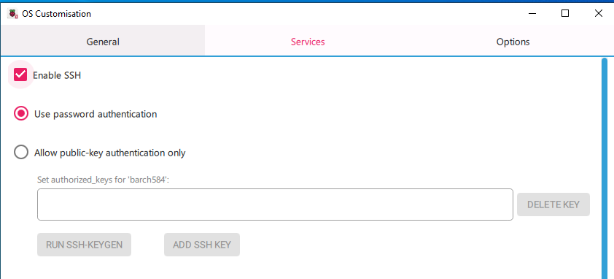
In the Options don’t change anything
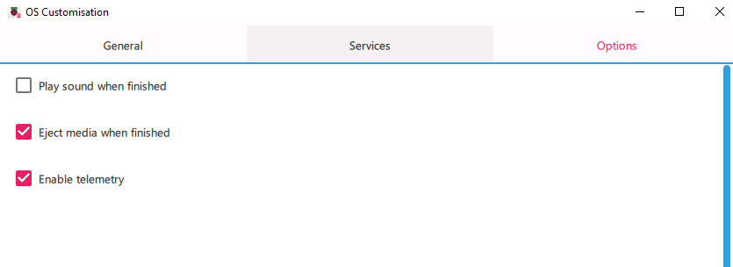

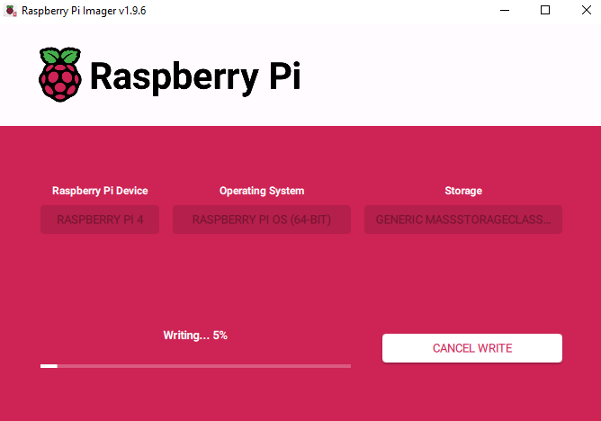

Test if it works firstly with a cmd. Type in ssh <username>@<hostname> which was for my case ssh barch584@PIbarch584
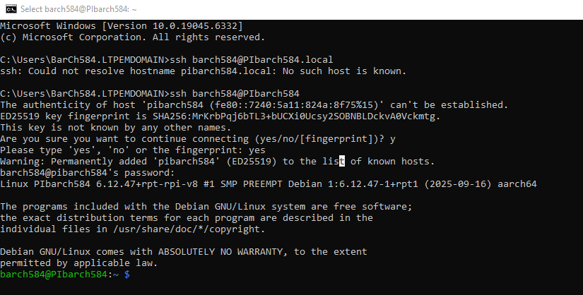

VNC viewer
To enable that you can access the desktop of the raspberry (with VNC viewer in this case) type in the cmd prompt (connected to the raspberry PI via SSH) sudo raspi-config
Select 3. Interface Options
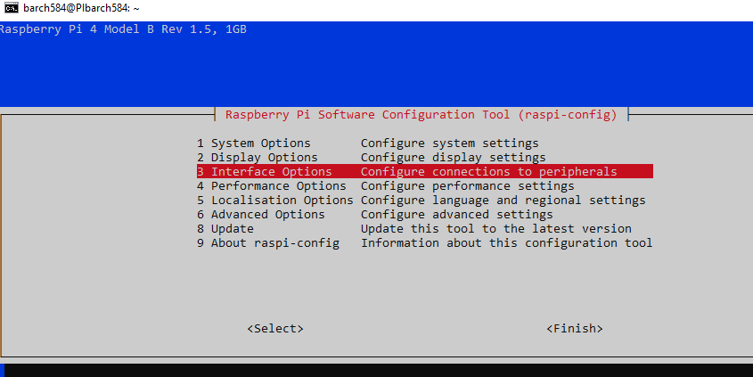
Select I3 VNC
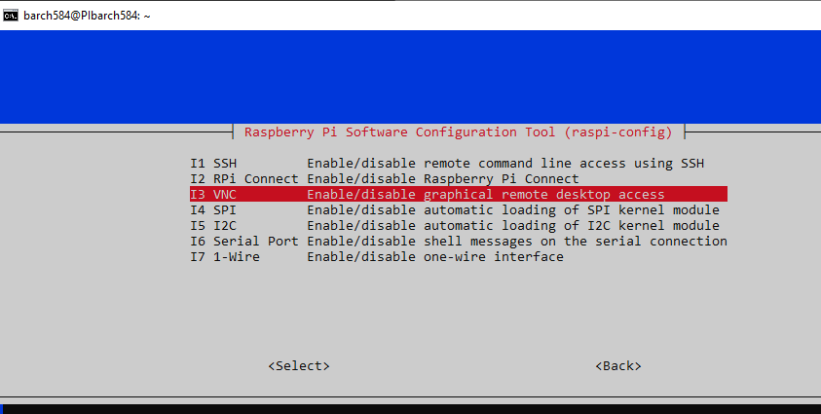

Select Yes
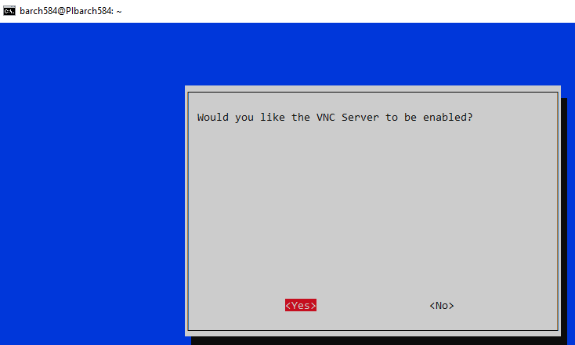
If successful it should display:
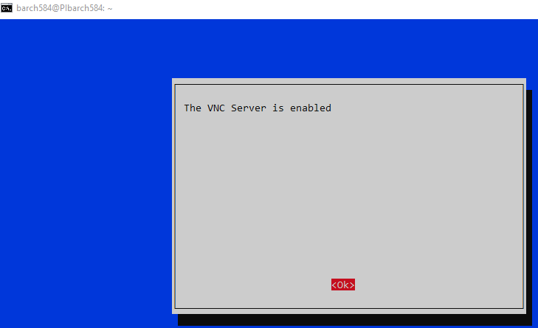
With the Tab key you can go to Finish
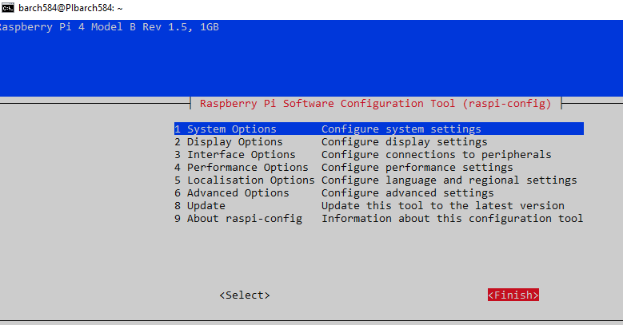

Now connect to it via VNC viewer:
(Open VNC viewer), Go to File > New connection
Type in the hostname of the PI in the VNC Server: give it a name of your liking in Name and select OK
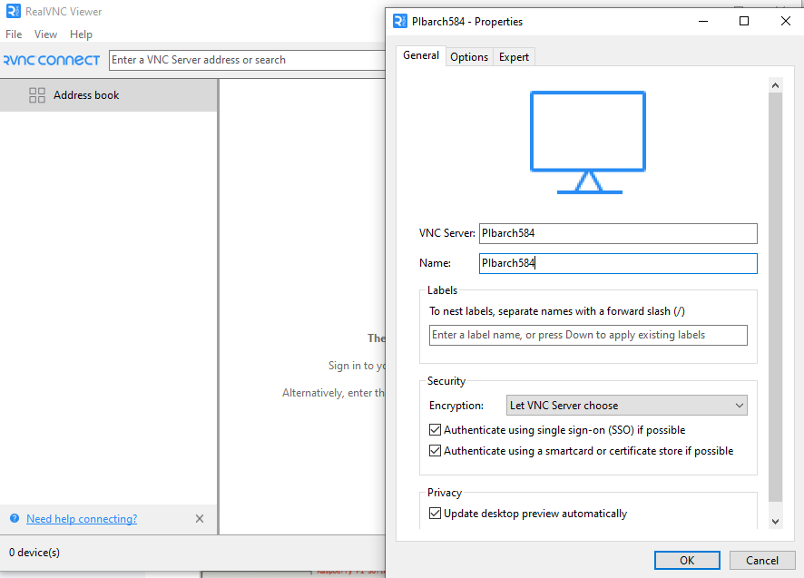
Double click the now created icon which has the name you entered earlier and if asked for the Identity Check window click Continue

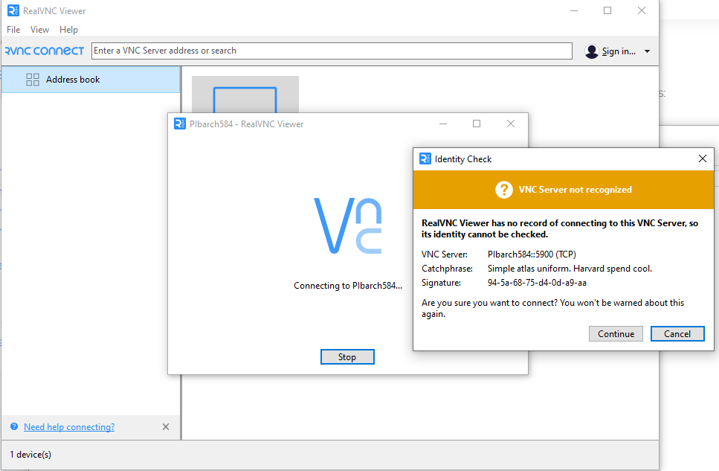

Type in the username & password setup earlier in the configuration of the raspberry PI and you can also select Remember password (not mandatory but practical)
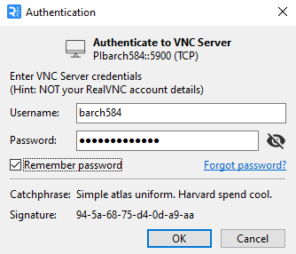

Now it is successfully connected via VNC, and you see the desktop of the raspberry.
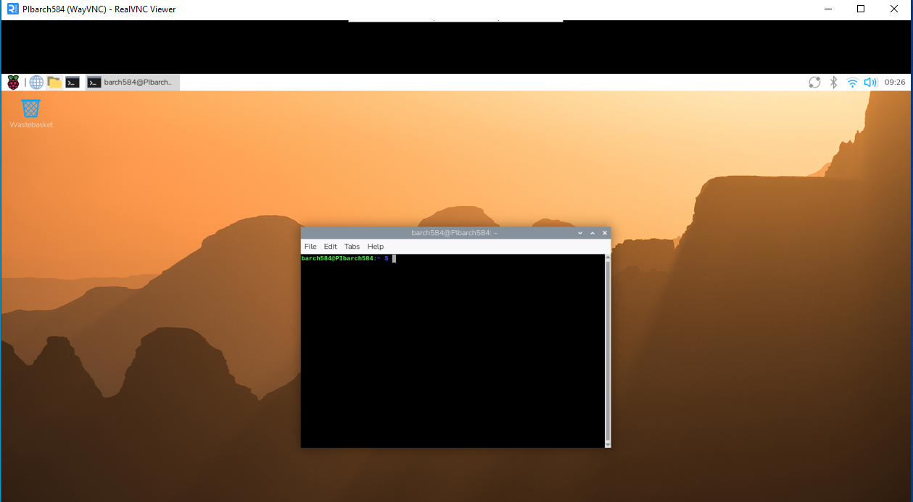

Configure static IP:

Open a terminal and type in sudo nano /etc/dhcpcd.conf and add on a new empty line:
(Note that vlan10 can have also a different number (it can also e.g. be 20, 30, or any other number & for the static_ip_address the last 3 digits are 212 because due to the PC number beeing 12 & the first digit was choosed by the organizers)
interface vlan10
static ip_address=192.168.4.212/24
static routers=192.168.4.1
static domain_name_servers=192.168.4.1

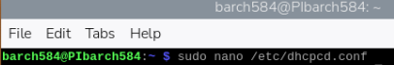
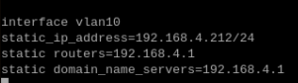
Next step is to install the dhcpcd library with the command
sudo apt install dhcpcd5 -y
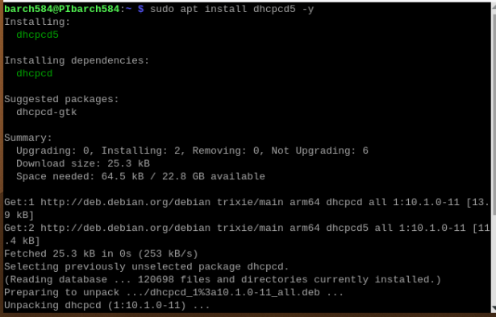
Lastly reboot the system by typing in sudo reboot now.

Enable I²C interface:
Go to 3. Interface Options
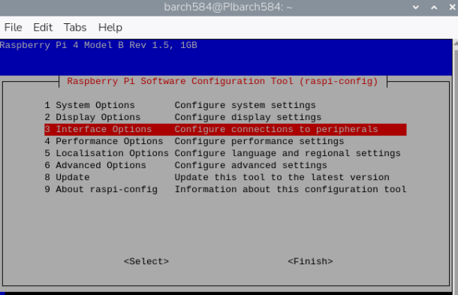
Go to I5 I2C and with the Tab key navigate to Yes to enable it and with Tab navigate to Finish
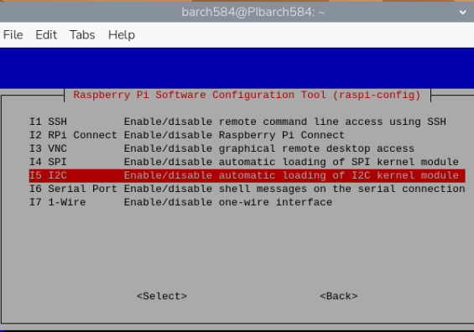
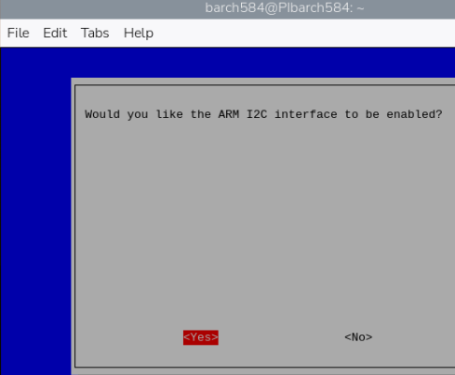
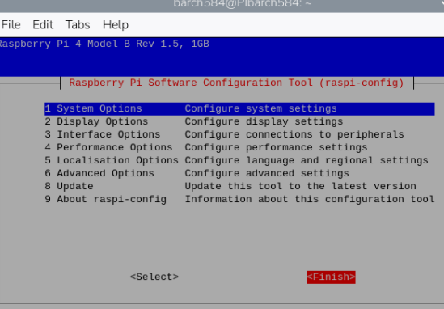

Docker installation
To install Docker in the Raspberry PI, use the resource provided on get.docker.com, meaning firstly download it with the command
curl -fsSL https://get.docker.com -o install-docker.sh
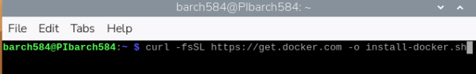
Verify the content of the script
Cat install-docker.sh
(This is the beginning of the script)
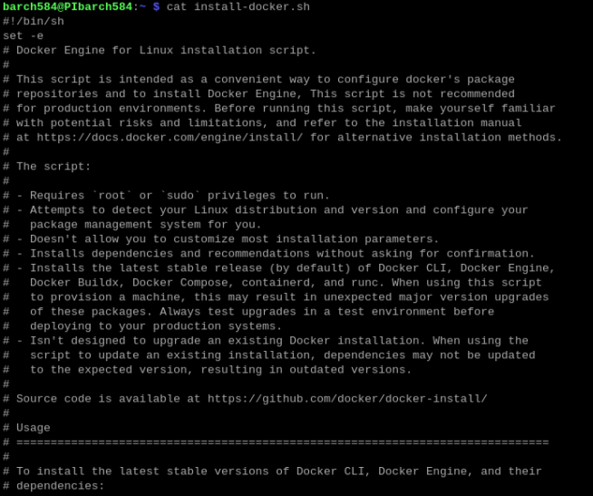

Now verify the scripts steps to verify that it would execute properly:
(The –dry-run parameter specifies that the terminal will display all the steps it did when it executed the script)
sh install-docker.sh –dry-run
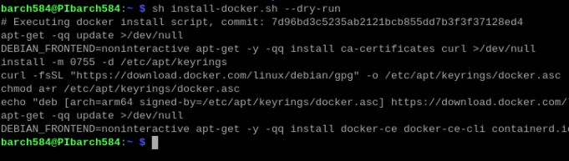
And to finally install it run
sudo sh install-docker.sh
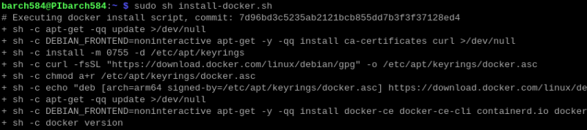
To verify that docker was successfully installed simply type in the command docker and check if it displays something like this (or similar)
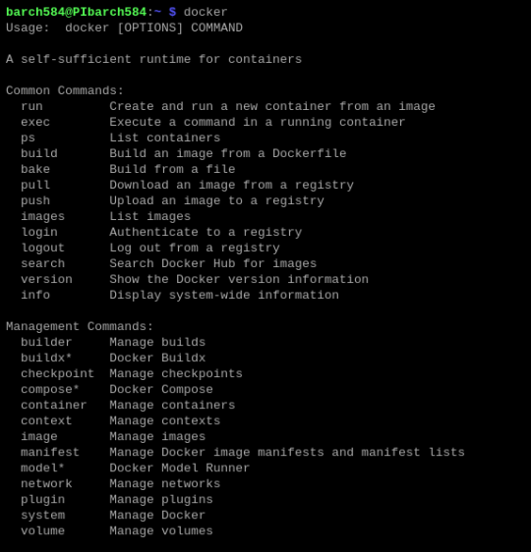

Screen orientation
After connecting & receiving the display parts & PI together and connecting to VNC it should like something like this
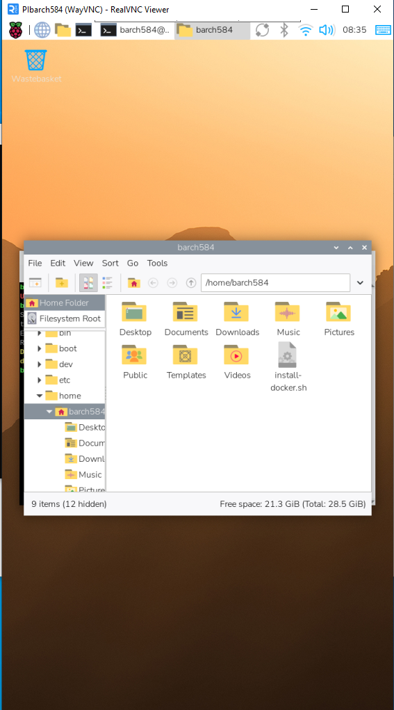

To change the orientation right click on the desktop > Desktop Prefences... >
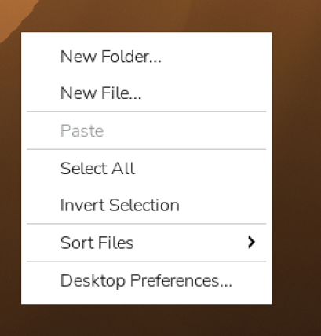
Scroll down to Screens
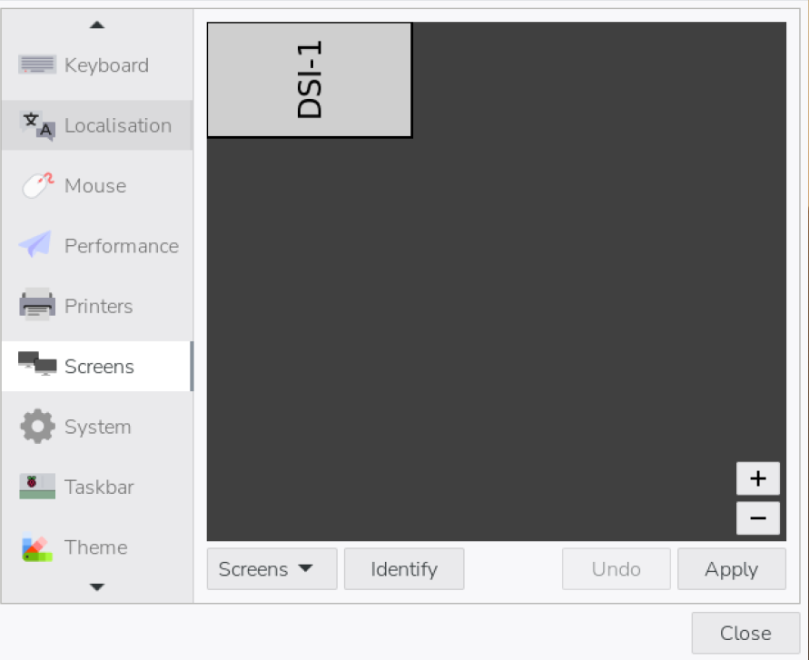
Click on Screens button > DSI-1 >Orientation > choose Right
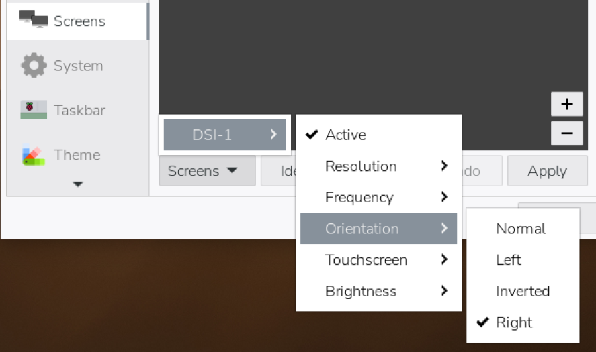
Reboot the machine & reopen VNC viewer

Disable on screen keyboard (optional)
Click on the raspberry PI logo > Preferences > Control Centre > Display
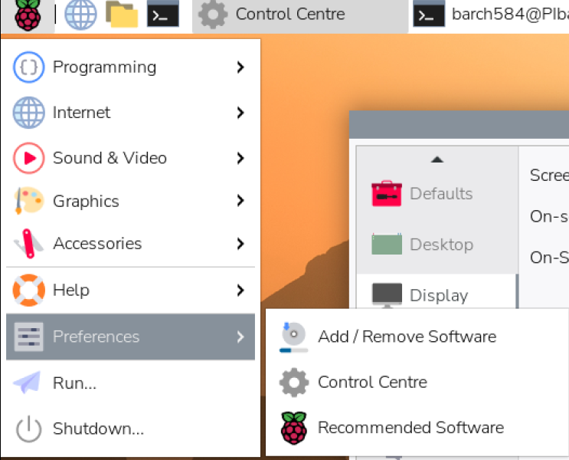
Change On-screen Keyboard: to Disabled
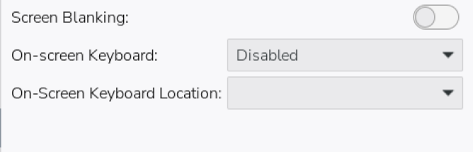

Create folder /opt/station & /opt/station/www & copy files
To create the 2 needed directories type in the termux:
cd /
sudo mkdir /opt/station
sudo mkdir /opt/station/www
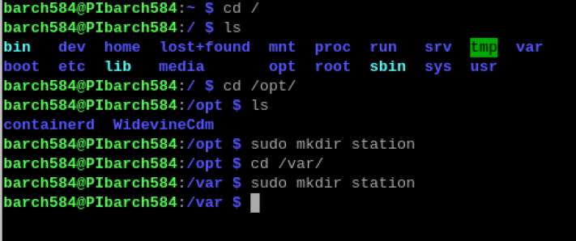
Now to move all firmware files:
sudo mv /home/barch584/Desktop/Ressourcen/Firmware\ und\ Scripts/* /opt/station/
Copy all the files in of the website folder in there:
sudo mv /home/barch584/Desktop/Ressourcen/Station-Webseite/* /opt/station/www

NOTE: Due to a incorrect information in the documentation I had to move all the website files in a newly created folder (/opt/station/www) from /var/www/html (so you can ignore the screenshot above) with the command:
sudo mv /var/www/html/* /opt/station/www

Create a docker container
With the following command you create a docker container & autostart with it unless the service is supposed to be disabled by the user:
docker run -d --name php --restart unless-stopped -p 8080:80 -v /tmp/station:/tmp/station -v /opt/station/www:/var/www/html php:8.4-apache
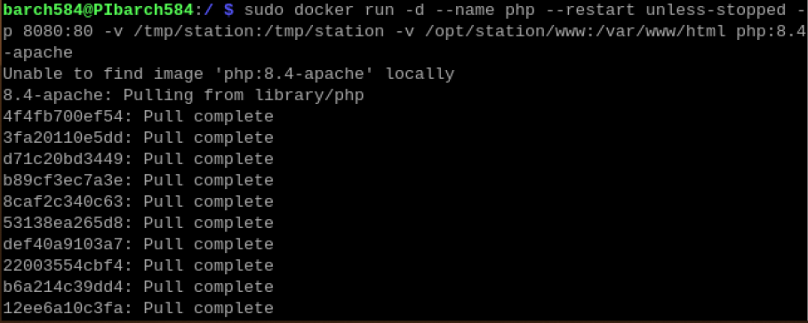

Configure autostart

sudo apt -y install wtype
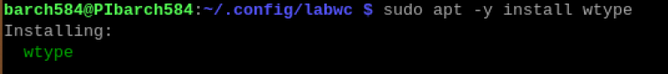

sudo nano .config/labwc/autostart
Type in the document:
sudo docker run -d --name php --restart unless-stopped -p 8080:80 -v /tmp/station:/tmp/station -v /opt/station/www:/var/www/html php:8.4-apache

chromium http://localhost:8080 https://time.is/London --kiosk --noerrdialogs --disable-infobars --no-first-run --enable-features=OverlayScrollbar --start-maximized & ~/switchtab.sh
NOTE: not all of the script fitted in the screenshot
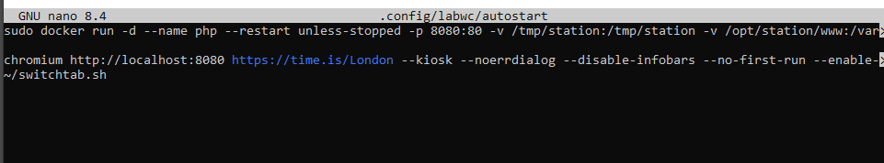

Next create and edit the file switchtab.sh in ~/switchtab.sh:
Add the following:
#!/bin/bash

chromium_pid=$(pgrep chromium | head -1)
while [[ -z $chromium_pid ]]; do
echo "Chromium browser is not running yet."
sleep 5
chromium_pid=$(pgrep chromium | head -1)
done
echo "Chromium browser process ID: $chromium_pid"
while true; do
# Send Ctrl+Tab using `wtype` command
wtype -M ctrl -P Tab -p Tab
sleep 10
done

Source for the script above: https://www.raspberrypi.com/tutorials/how-to-use-a-raspberry-pi-in-kiosk-mode/
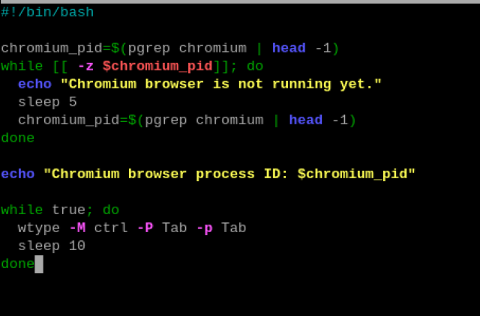

Next edit the permissions for the switchtab.sh that it can run without sudo
chmod +x ~/switchtab.sh
Now to set it in kiosk mode simply reboot
(OPTIONAL: FOR DEACTIVATING)
To be able for myself to take further configuration I commented the autostart files content with sudo nano ~/.config/labwc/autostart & adding hashtags at the beginning of both lines. Otherwise you could also access it remotely via a cmd with ssh, comment it there and reboot the PI

Create folder /tmp/station
Already created by the docker command

Redirect sensor readings to result.csv
Create the result.csv file:
cd /tmp/station
sudo nano result.csv
NOTE: you may have to type something in the file for linux to be able to save it (the content does not matter)
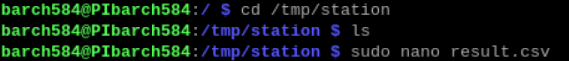
Redirect to that csv file by opening sudo nano /opt/station/www/index.php
Make sure the directory is set correctly to /tmp/station/result.csv like shown in the screenshot.

MySQL setup

Mysql Database
The full database script is in database.sql. I created all 4 tables (Users, Stations, Collections & measurements)
Users table contains:
- Username (type: varchar & PK)
- First_name (type:varchar)
- Last_name (type:varchar)
- Adminflag (type: boolean)
Stations table contains
- serial_number (type: varchar & PK)
- name (type: varchar & PK)
- description (type: varchar & PK)
Measurements table contains
- id (type: int & auto_increment & primary key)
- timestamp (type: timestamp & default current_timestamp)
- temperature (type: int)
- humidity (type: int)
- air_pressure (type: int)
- light_intensity (type: int)
- air_quality (type: int)
Collections table contains
- name (type: varchar & primary key)
- description (type: varchar)
User_friends table contains
- user_id (type: int & PK)
- friend_id (type: int & PK)
- FK user_friends.user_id -> users.user_id
- FK user_friends.friend_id -> users.user_id

EDITS:
- Added password, email, and role to Users for authentication and authorization.
- Replaced Adminflag with role-based access control.
- Linked Stations to Users using a foreign key (station ownership).
- Increased measurement precision by changing values from INT to DECIMAL.
- Linked Measurements to Stations using a foreign key.
- Replaced collection name primary key with an auto-incremented ID.
- Linked Collections to their creating users.
- Added tables for:
  - measurement–collection relationships,
  - user access to collections,
  - friendship management with status tracking.
- Improved normalization and referential integrity across the schema.

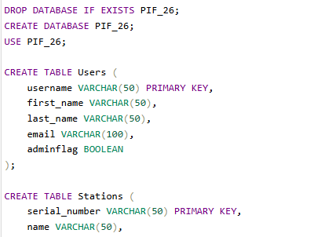
If copy pasted into phpMyAdmin editor & upon execution you should get something like this returned:
(NOTE: The local webserver used was Apache in this case in combination with phpMyAdmin in a xampp environment)
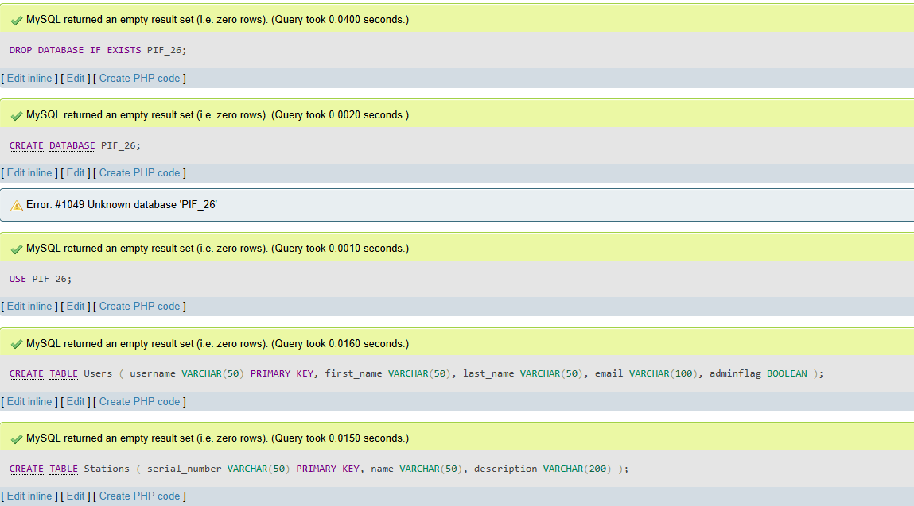
On the left of phpmyadmin there should be a database with the name PIF_26 to be seen with the corresponding tables as shown below:
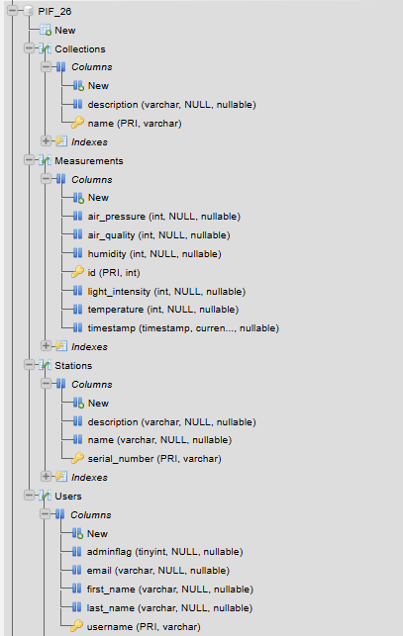

Conceptual data model
Here is the conceptual data model:
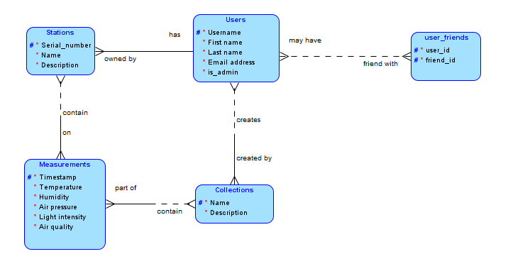

Logical data model

Here is the logical data model:
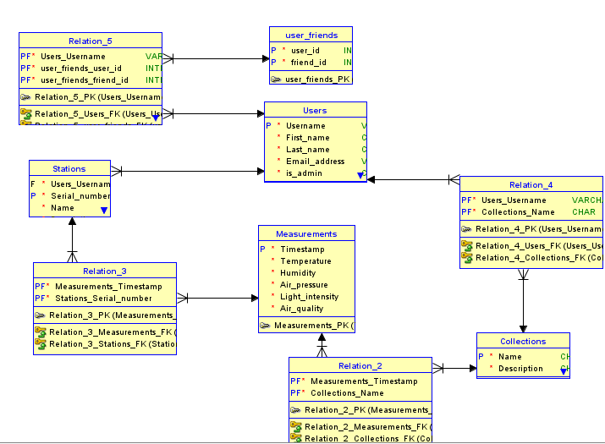

Webserver

Notes:
For this documentation I used the raspberryPi to install & configure everything mentioned in the user story.
Before starting everything it is a good idea to have everything up-to-date by running in the terminal sudo apt update && sudo apt upgrade -y

Apache installation
Install apache by typing sudo apt install apache2

MariaDB installation
Install mariadb with sudo apt install mariadb-server

PHP installation
Install php with sudo apt install php

phpMyAdmin installation
Install phpMyAdmin with sudo apt install phpmyadmin
On this window select Yes
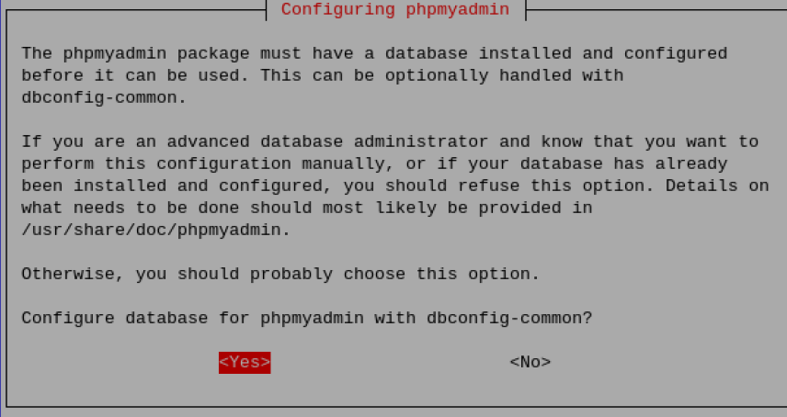

Then input your password for phpmyadmin to register (and confirm it).
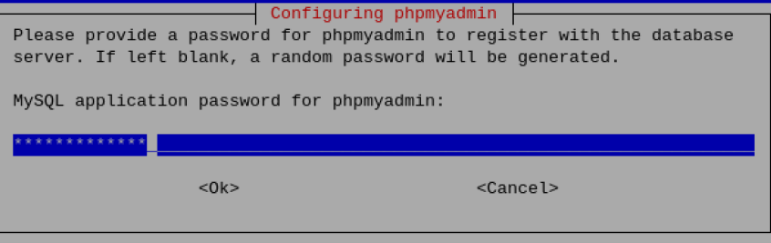
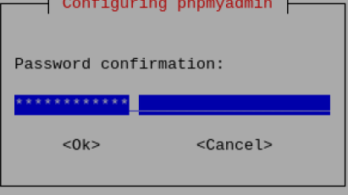
During the installation select on this window apache2.
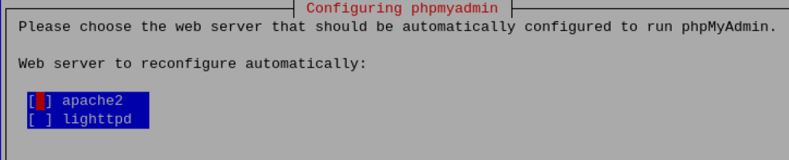
Afterwards the basic installation is completed.

phpMyAdmin configuration

Administrator account
You also need for this to work in a web browser to include it in the apache2.conf file. For that simply type in sudo nano /etc/apache2/apache2.conf

And include at the top of the file: Include /etc/phpmyadmin/apache.conf
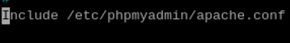
Now let’s start by actually creating a user account to login into phpmyadmin, for which you start with sudo mysql.
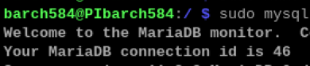
Now type in CREATE USER '<yourusername>'@'localhost ' IDENTIFIED BY '<yourpassword>';
Example: CREATE USER 'barch584'@'localhost ' IDENTIFIED BY 'rootUSER123';
And now with the user created give the user the needed permissions. (For this documentation to make it the easiest possible I will grant all permissions on the localhost to be an administrator account)
GRANT ALL PRIVILEGES ON *.* TO '<yourusername>'@'localhost' WITH GRANT OPTION;
Example: GRANT ALL PRIVILEGES ON *.* TO 'barch584'@'localhost' WITH GRANT OPTION;
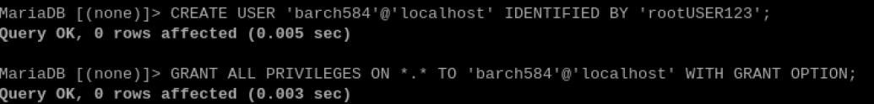
And by starting a browser and going to the link localhost/phpmyadmin/ the following window should appear in the tab in which you simply type in your credentials created earlier in mysql:
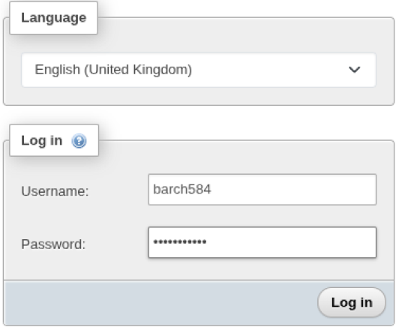
And afterwards your view looks something like this (or similar).
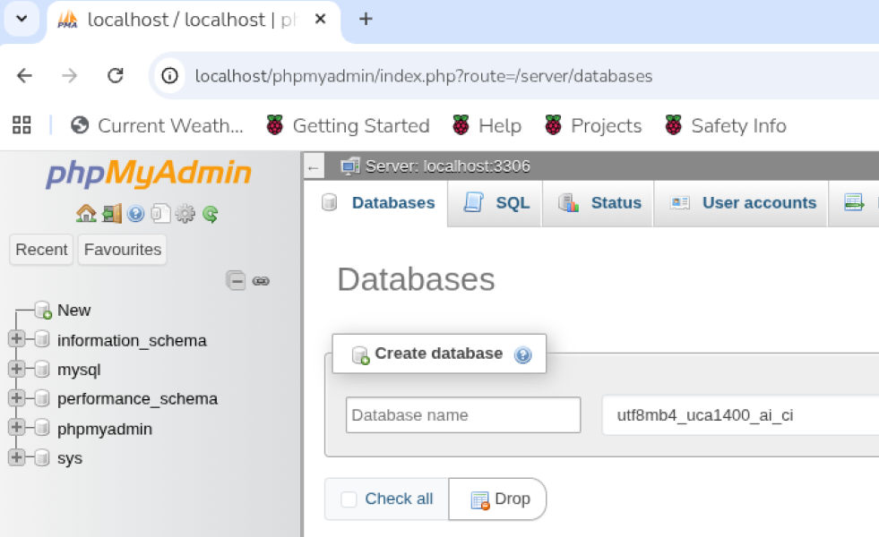

Restricted account
Create a new user account with a custom password which should be as secure as possible:
CREATE USER 'restricteduser'@'localhost' IDENTIFIED BY 'loca1GUE$T';
And assign this restricteduser which is the end consumer account the SELECT & INSERT rights:
GRANT SELECT,INSERT ON portableindoorfeedback.* TO 'restricteduser'@'localhost' WITH GRANT OPTION;

Install openssl and create self-signed SSL certificate
First install openssl with sudo apt install openssl
In my case it was already installed but this may vary.
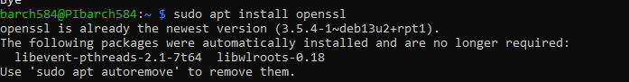
Before creating the key I created the appropriate folder for this:
sudo mkdir -p /etc/ssl/private
sudo chmod 700 /etc/ssl/private
Now generate the x509 certificate for the CA. With sudo openssl req -new -x509 -nodes -days 365 -newkwy rsa:2048 -keyout /etc/ssl/private/apache-selfsigned.key -out /etc/ssl/certs/apache-selfsigned.crt
In this case it would be for the prompts asked:
- LU
- Luxembourg
- Luxembourg
- REPIF_barch
- NOTHING HERE
- Pibarch584.lu OR <yourspecified hostname> OR <your IP> OR localhost
- barch584@school.lu OR <youremailaddress>
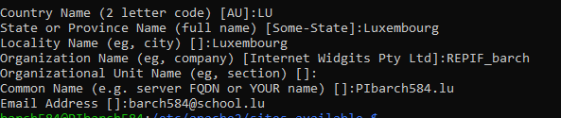
Make that only the root user can change the key, enable ssl & restart the server:
sudo chmod 600 /etc/ssl/private/apache-selfsigned.key
sudo a2enmod ssl
sudo systemctl restart apache2
Now a new or even existing virtualhost file is needed to be (re)configured. For that, type in cd /etc/apache2/sites-available/ and create a new file, I named mine ssl-site.conf with sudo nano ssl-site.conf
NOTE: In following screenshot I did it without the cd, but for the next commands I highly recommend to make it easier to navigate directly to the directory
Now add the following text inside of it:

<VirtualHost *:443>
ServerName PIbarch584.lu
ServerAlias www.PIbarch584.lu
DocumentRoot /var/www/html
SSLEngine on
SSLCertificateFile /etc/ssl/certs/apache-selfsigned.crt
SSLCertificateKeyFile /etc/ssl/private/apache-selfsigned.key
</VirtualHost>

It simply enables that on port 443 (https) use the self-signed certificate created earlier within the directory /var/www/html and use the normal log files.
Also the Servername & ServerAlias need to be changed depending on if you used an IP, localhost or a hostname in your certificate.
In my case I used a hostname named christian.lu created in earlier assignments and implemented it in there.
You simply modify hosts file with sudo nano /etc/hosts and add <yourIP> and the name from which it should resolve to that IP, like so:
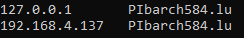
192.168.4.137 Pibarch584.lu
127.0.0.1 Pibarch584.lu
Now save the file, restart the server and check in the status that the server is running correctly:
sudo systemctl restart apache2
sudo systemctl status apache2
When typing the status command check that it displays some things in green like enabled and active like in the screenshot below:
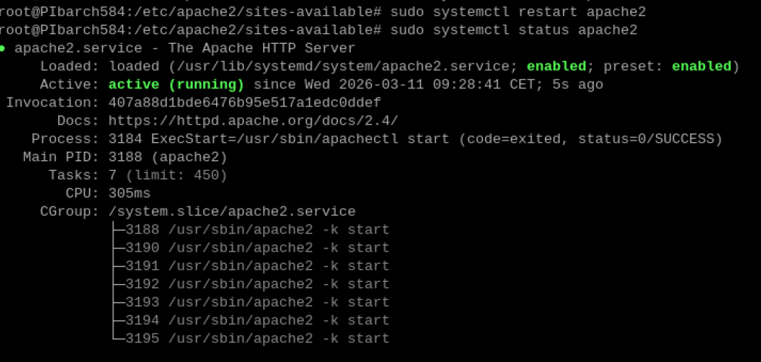
You may also need to enable the new configuration file:
sudo a2ensite /etc/apache2/sites-available/ssl-site.conf
And by opening a web browser and going to that website, click on the Not secure button in the tab bar & click Certificate Details
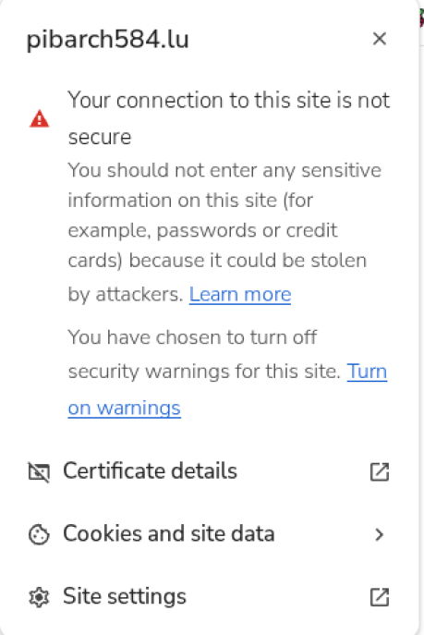
Click on Certificate details

And there it should write the details of the certificate:
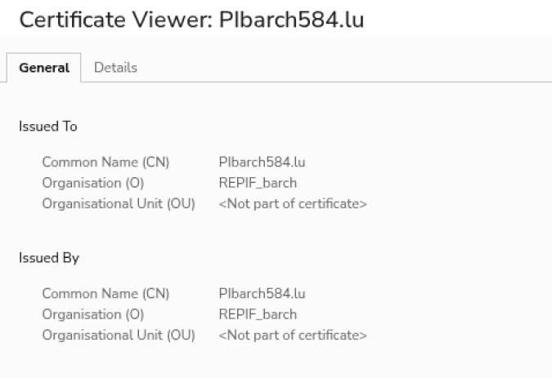
NOTE: for this all to work you must also complete the steps below in Redirect HTTP traffic to HTTPS

Redirect HTTP traffic to HTTPS
Start by modifying the 000-default.conf file with:
sudo nano /etc/apache2/sites-available/000-default.conf
Inside the <VirtualHost *:80> tags type in:
ServerName christian.lu
Redirect permanent / https://christian.lu/
Save the file and now all traffic is redirected from http -> https.
NOTE: again if you used localhost, IP or another hostname replace the link in Redirect permanent with whatever you configured earlier. In my case I choosed a DNS named christian.lu configured in earlier assignments.

Data transfer

Config.toml
Firstly go to the config.toml file and start by changing the station_serial to a valid station registered in the database.
Change the IP to your host PC's IP. 192.168.4.18 was it in my case but this may vary. In addition to that write the path to the receiver file.
NOTE: There must be a / before the rest of the filepath
The result should look something like this:
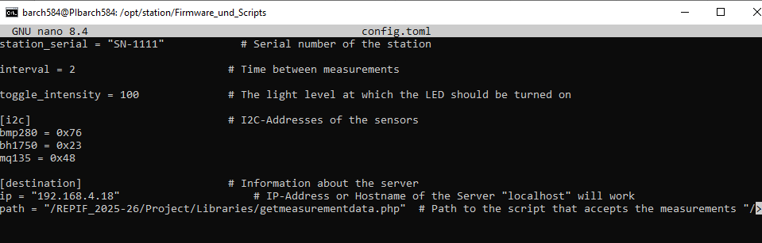
Next let's create the receiving file which is called (in this case) getmeasurementdata.php. It must be in the folder where you specified it in the config.toml file.

Receiver php script
The following script first gets the measurements via post request and simply inputs them into the database with an insert stmt. In bind_param you may have noticed that that d standing for double which simply means it expects numbers which could contain a comma and not entire numbers.
Now here is the content of the file:

<!DOCTYPE html>
<html lang="en">
<head>
<meta charset="UTF-8">
<meta name="viewport" content="width=device-width, initial-scale=1.0">
<title>Insert Measurement</title>
</head>
<body>
<?php
include("conndb.php");
$temperature = $_POST['temperature'];
$humidity = $_POST['humidity'];
$pressure = $_POST['pressure'];
$light = $_POST['light'];
$gas = $_POST['gas'];
$station = $_POST['station_serial'];
$timestamp = $_POST['timestamp'];
$sqlInsert = $conn->prepare("INSERT INTO measurements (temperature, humidity, pressure, light, gas, timestamp, fk_station_records) VALUES (?,?,?,?,?,?,?)");
$sqlInsert->bind_param("dddddss", $temperature, $humidity, $pressure, $light, $gas, $timestamp, $station);
$sqlInsert->execute();
?>
</body>
</html>
To correctly implement it, it must match the table names in your measurement table and also pay attention what you named your measurement table.
It also needs the correct connection data (to the database)
As you may notice mine is called measurements but change it if it is different.
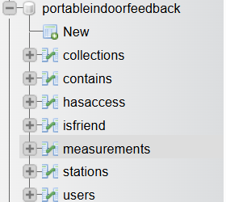
Here is the structure of the table but this as well may be different.
After confirming and having it implemented save it and check that the file location is correct as well as its filename.
Now after starting everything, which means having the raspberrypi on (with autostart activated with the proper content), turning on xampp (Apache & MySQL) it should return you results
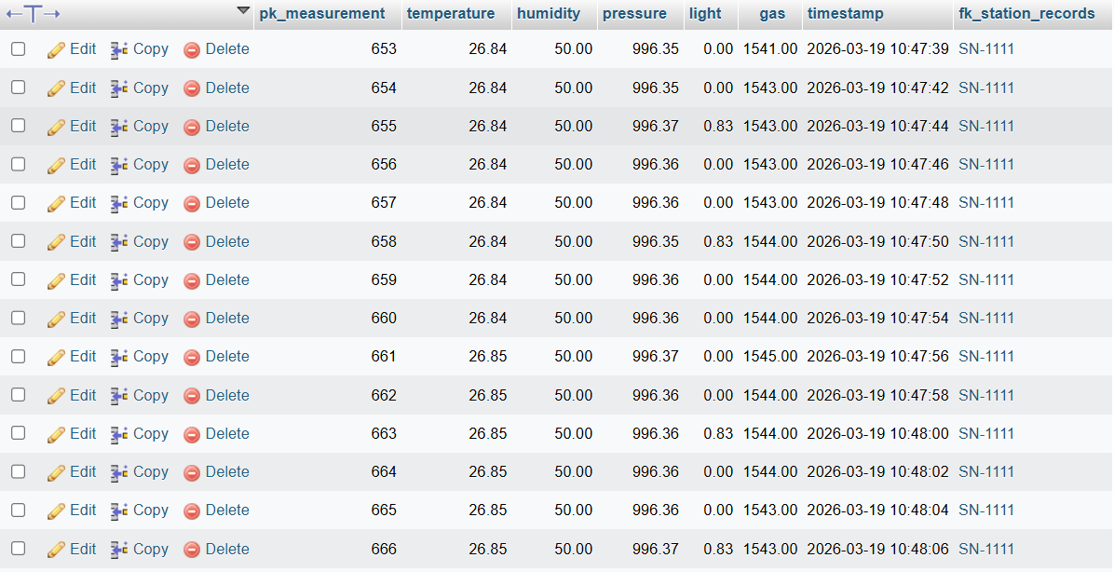

Autostart configuration
Here is the autostart configuration which is located in ~/.config/labwc/autostart:
mkdir -p /tmp/station
python3 /opt/station/Firmware_und_Scripts/measure.py > /tmp/station/result.csv &
sudo systemctl start docker
docker start php
sleep 5
chromium http://localhost:8080 \
--kiosk --noerrdialogs --disable-infobars --no-first-run \
--enable-features=OverlayScrollbar --start-maximized &
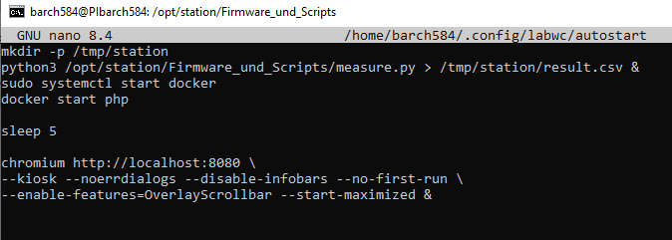

Measurements file
Now for the form which can import test data, here is my design of my form but this of course may vary. This is in my measurements.php file and looks like this:
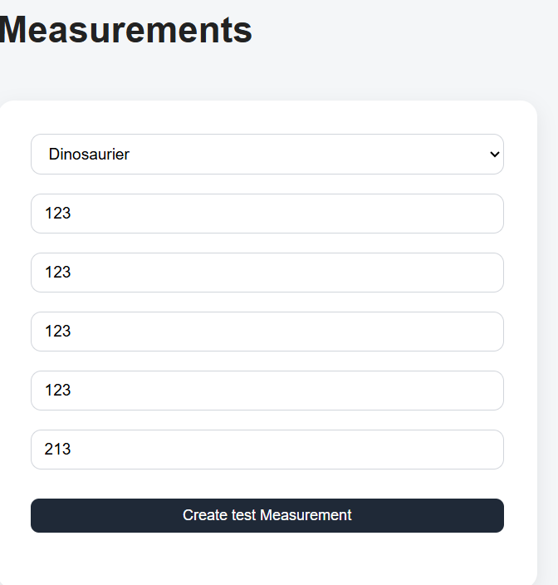
And the data gets later shown on the website 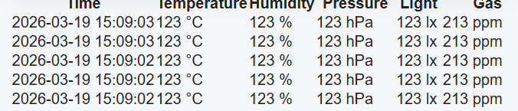
And the db:
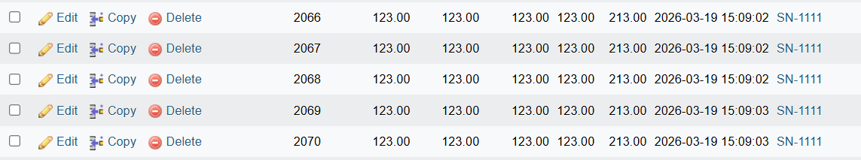

The following script allows to insert data into the database. Simply by making a $.post request, give it the data and insert it. By updating the table you instantly get the new value. The filter is still experimentative and not working yet and the clearfilter simply resets the value of the table & the input fields where you could filter by dates & times.
Below is the current measurements.php script for the form:

<!DOCTYPE html>
<html>

<head>
<title>Measurements</title>
<link rel="stylesheet" href="../Styles/styles.css">
</head>

<body class="light-theme">
<script src="../Libraries/JS/jquery-3.7.1.min.js"></script>
<?php
include("../Libraries/navbar.php");
include("../Libraries/conndb.php");
include("../Libraries/createmeasurement.php");
?>
<?= createnavbar("Measurements"); ?>
<h1>Measurements</h1>
<?php
$selectstationsstmt = $conn->prepare("SELECT * FROM stations WHERE fk_user_owns = ?");
$selectstationsstmt->bind_param("i", $_SESSION['username']);
$selectstationsstmt->execute();
$result = $selectstationsstmt->get_result();
?>
<div class="form-card">
<div class="form-group">
<select name="stationslist" id="stationslist">
<?php
while ($row = $result->fetch_assoc()) {
echo "<option value='" . $row['pk_serialNumber'] . "'>" . htmlspecialchars($row['name']) . "</option>";
}
?>
</select><br>
<input type="text" placeholder="Temperature (in °C)"><br>
<input type="text" placeholder="Humidity (in %)"><br>
<input type="text" placeholder="Pressure (in hPa)"><br>
<input type="text" placeholder="Light (in lx)"><br>
<input type="text" placeholder="Gas (in kOhm)"><br>
<button type="submit" value="Create measurement" id="createMeasurementButton">Create test Measurement</button>
</div>

</div>
<div class="form-card">
<div class="form-group">
<label>From</label>
<input type="datetime-local" id="fromTime">
</div>

<div class="form-group">
<label>To</label>
<input type="datetime-local" id="toTime">
</div>

<button id="filterTime">Filter</button>
<button id="clearFilter">Clear</button>
</div>

<table id="tablemeasurements">
<tr>
<th data-col="0">Time <span class="arrow"></span></th>
<th data-col="1">Temperature <span class="arrow"></span></th>
<th data-col="2">Humidity <span class="arrow"></span></th>
<th data-col="3">Pressure <span class="arrow"></span></th>
<th data-col="4">Light <span class="arrow"></span></th>
<th data-col="5">Gas <span class="arrow"></span></th>
</tr>
</table>

<script>
let sortDirections = {};
let activeColumn = null;
$("#createMeasurementButton").click(start);
// ---------- LOAD DATA ----------
function start() {
$.post("../Libraries/createmeasurement.php", {
stationslist: $("#stationslist").val(),
temperature: $("input[placeholder='Temperature (in °C)']").val(),
humidity: $("input[placeholder='Humidity (in %)']").val(),
pressure: $("input[placeholder='Pressure (in hPa)']").val(),
light: $("input[placeholder='Light (in lx)']").val(),
gas: $("input[placeholder='Gas (in kOhm)']").val()
}, function(data) {
$("#tablemeasurements tr:first").after(data);
applyCurrentSort();
});
}
function loadMeasurements() {
$.post("../Libraries/showmeasurements.php", {
station: $("#stationslist").val()
}, function(data) {
$("#tablemeasurements").append(data);
});
}
loadMeasurements();
// ---------- TIMESTAMP FILTER ----------
$("#filterTime").click(function() {
let from = $("#fromTime").val() ? new Date($("#fromTime").val()) : null;
let to = $("#toTime").val() ? new Date($("#toTime").val()) : null;

$("#tablemeasurements tr:gt(0)").each(function() {
let timeText = $(this).children("td").eq(0).text().trim();
let rowTime = new Date(timeText);
let show = true;
if (from && rowTime < from) show = false;
if (to && rowTime > to) show = false;

$(this).toggle(show);
});
});
$("#clearFilter").click(function() {
$("#fromTime, #toTime").val("");
$("#tablemeasurements tr").show();
});
</script>
</body>

</html>

Backup server

Allow external MySQL database access & restricted account
Let’s start with the 50-server.cnf config file to allow external connections:
Sudo nano /etc/mysql/mariadb.conf.d/50-server.cnf
Change the bind-address to 0.0.0.0
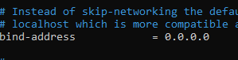
Next create the user with a password with this command. It authorizes the user to have as demanded full access to the entire portableindoorfeedack db. Click on Go to execute it:
CREATE USER 'pifuser26'@'%' IDENTIFIED BY ' PIFu$er123';
GRANT ALL PRIVILEGES ON portableindoorfeedback.* TO 'pifuser26'@'%';
FLUSH PRIVILEGES;
CREATE USER 'pifuser26'@'host.docker.internal' IDENTIFIED BY 'PIFu$er123';
GRANT ALL PRIVILEGES ON portableindoorfeedback.* TO 'pifuser26'@'host.docker.internal';FLUSH PRIVILEGES;
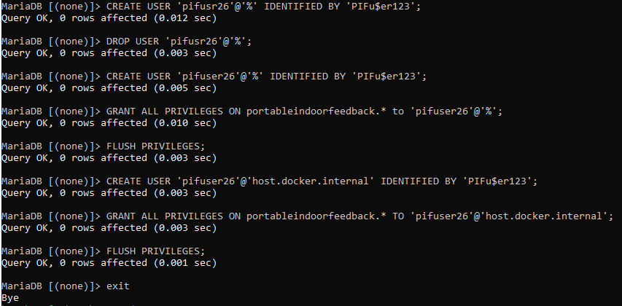

Create a new virtual machine
For that I created a new VM:
- RAM: 12GiB
- CPU cores: 4
- Storage: 50GB
- OS: Ubuntu Server
And a username & password are needed as well:
Username: <yourIAM>
Password: <yourstrongpassword>
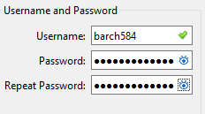
Upon startup configure your keyboard layout & update everything:
sudo dpkg-reconfigure keyboard-configuration
sudo apt update && sudo apt upgrade -y
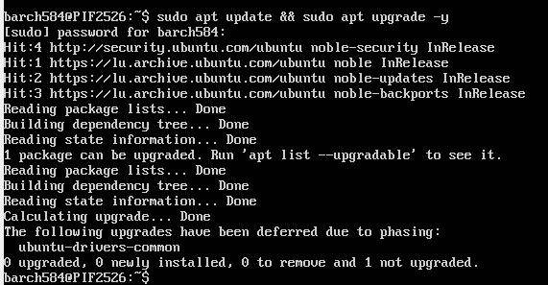

And of course, do not forget to reboot to apply all changes:
sudo reboot
Also, it is a good idea to install openssh-server with:
sudo apt install openssh-server

Export database setup
The first step is to create a new folder wherever you want, but it needs writing permissions. (For testing purposes I will give everyone writing permissions):
Sudo mkdir ~/mysqlbackups
Sudo chmod 777 ~/mysqlbackups
I also would highly recommend to create a .my.cnf file to not have to type a password each time. For that, create a new file in your home directory:
cd ~
sudo nano .my.cnf
And inside of it, type in the following:
[client]
User=<yourdbusername>
Password=<yourdbuserpassword>
Host=<ipofyoursqlserver>
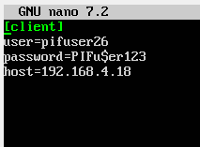
Now simply create a first test backup:
mysqldump --column-statistics=0 portableindoorfeedback > ~/mysqlbackups/db.sql
And the file gets created afterwards.
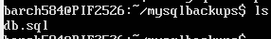

Crontab

Let’s automate it by applying the command with a crontab and giving it better more distinguishing names:
0 8 * * * mysqldump --column-statistics=0 portableindoorfeedback > $HOME/mysqlbackups/db_$(date +\%Y-\%m-\%d_\%H-\%M-\%S).sql

Workshop

PVC plates assembly

Display plate
This is the starter display plate
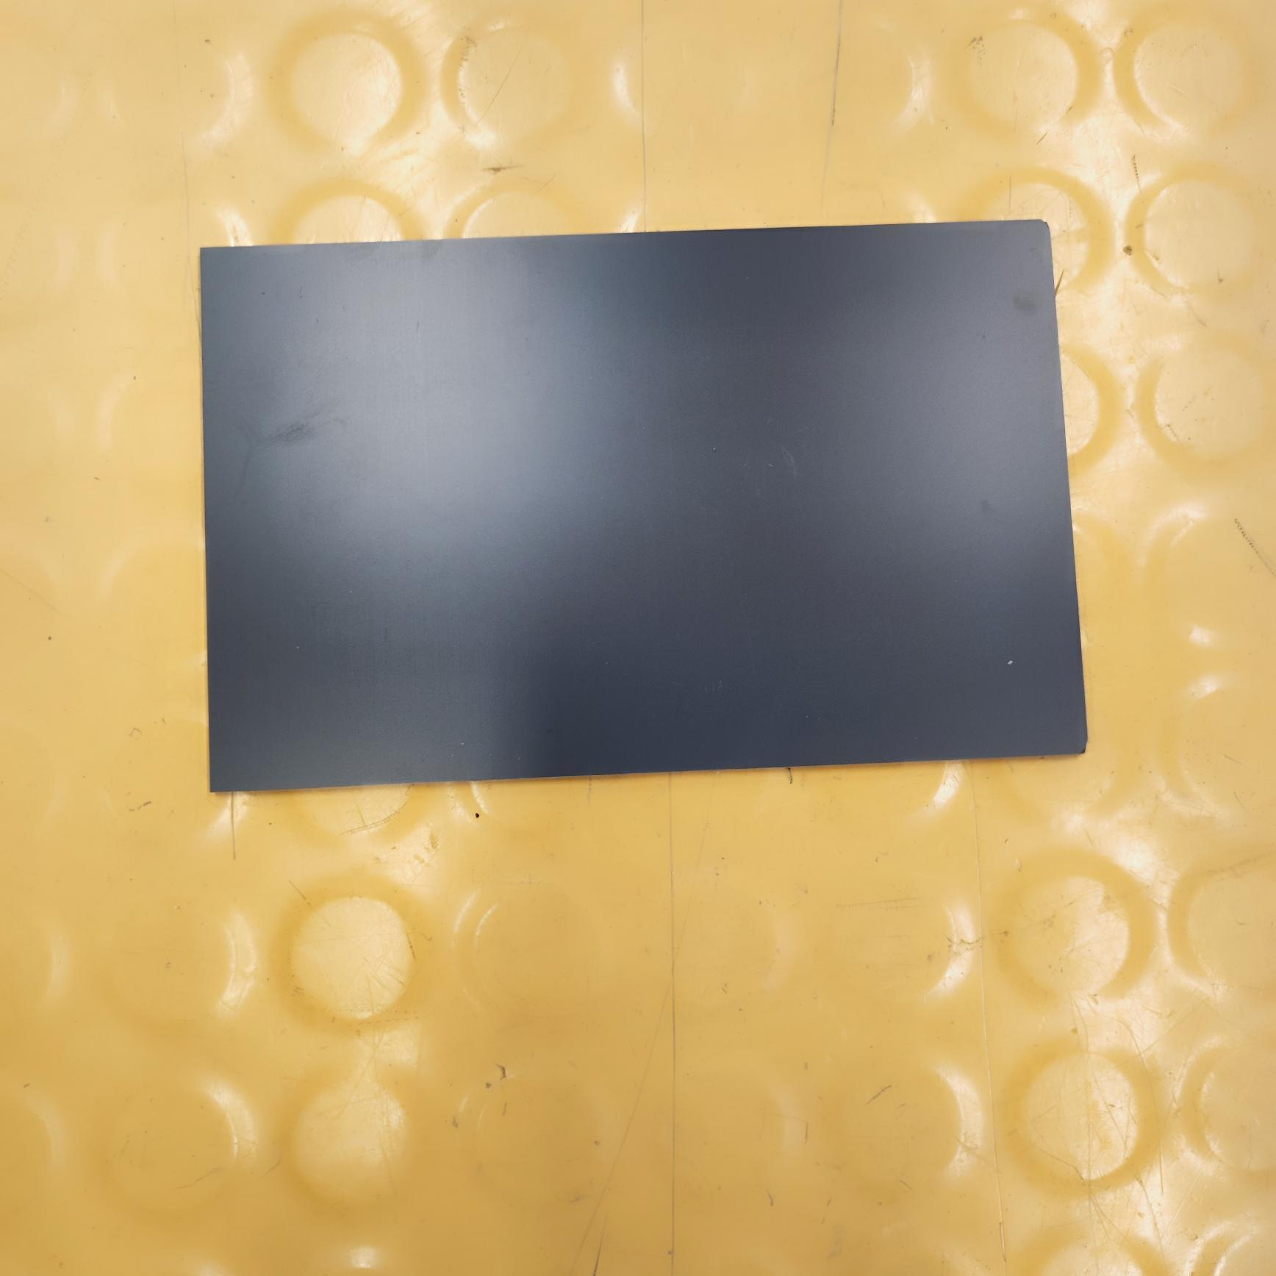

The display plate got in the first step everything cut into it with a scribing block according to the schematic to later have it center punched. This made sure that every drilling was smooth and more precise.
The first holes drilled into were the 3 holes (3mm) to connect the display & base plate together later. Next for the big “square” more to the center of the plate I used a step bit until the maximum size to open it up to some extend already.
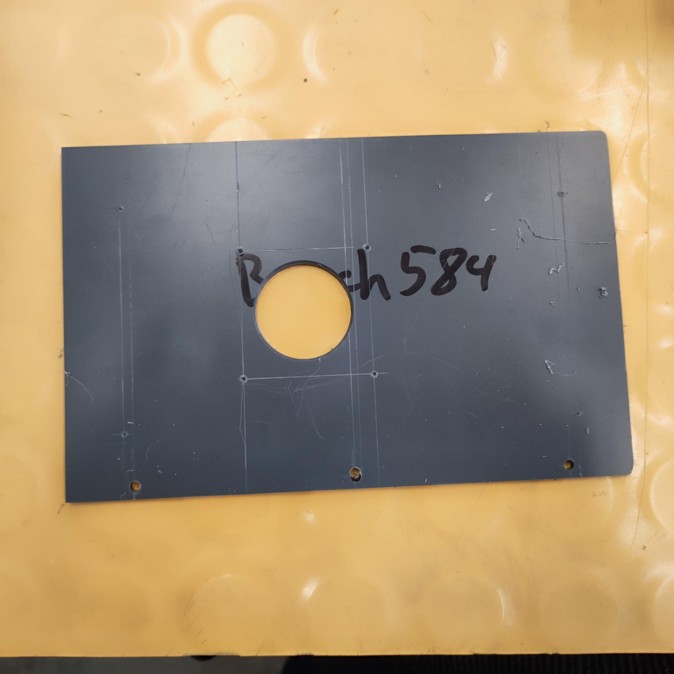

Afterwards I filed the previous created circle into an actual square with a dimension of 40*40mm. Quickly followed by drilling all remaining 2.5mm holes remaining according to the schematic to later attach a display to it.
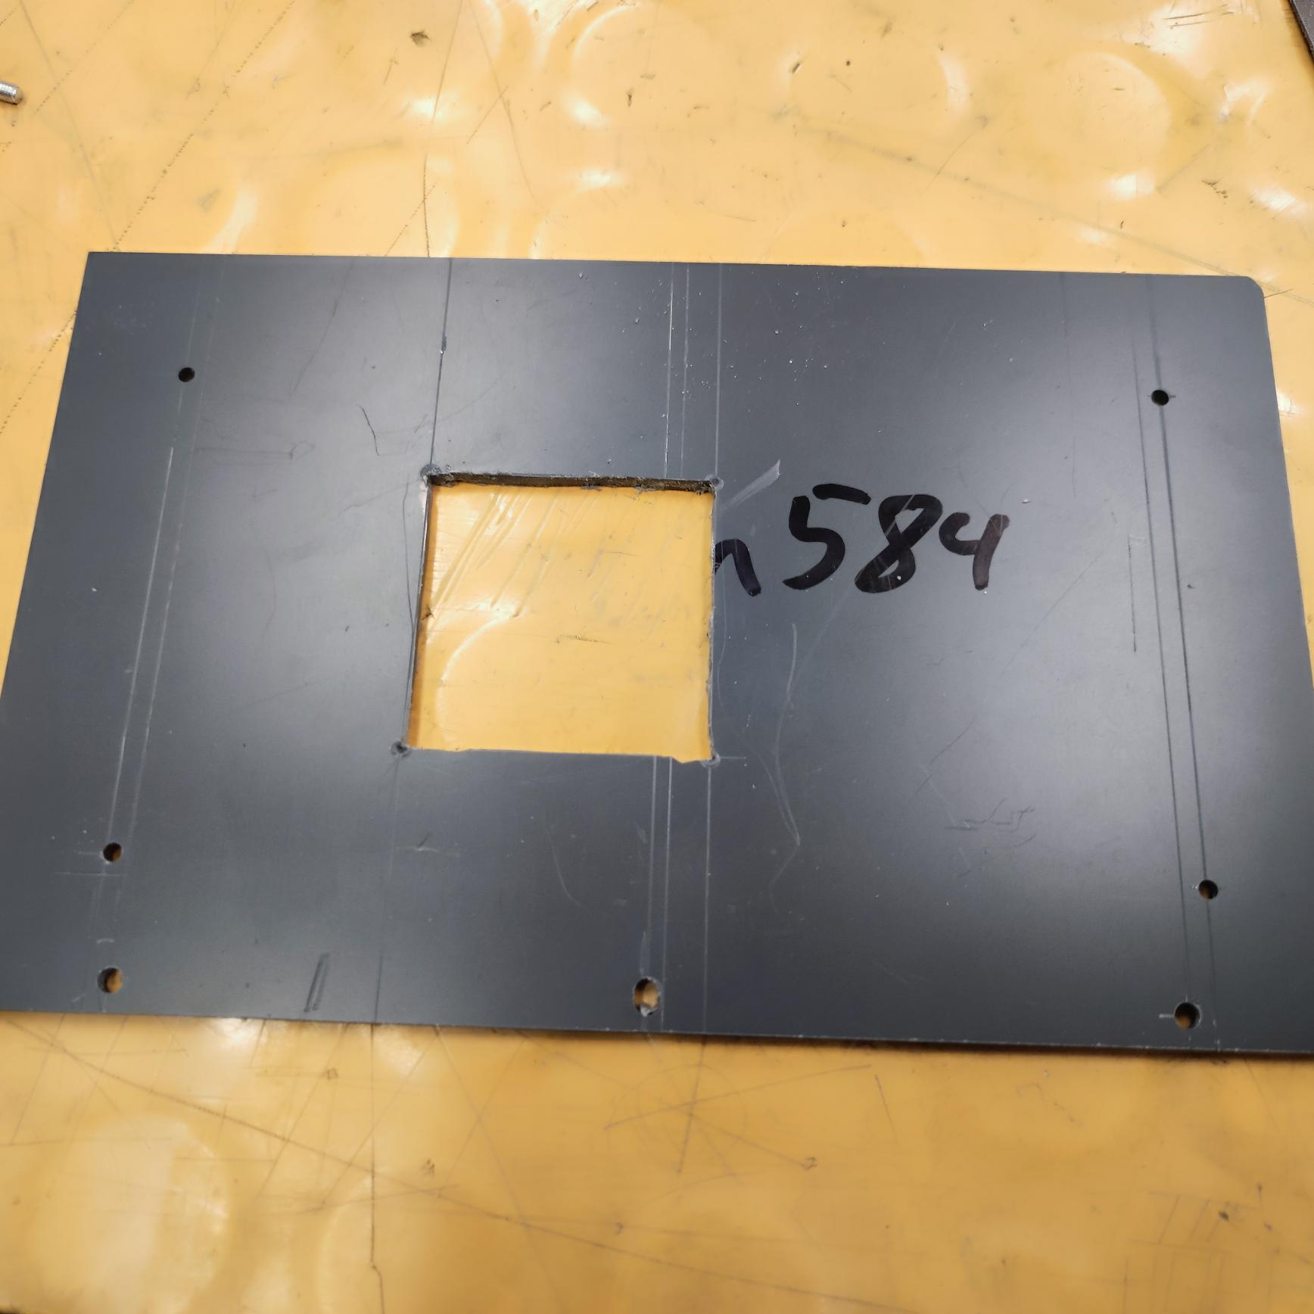

The base plate:
Like the previous plate I cut into it with a scribing block according to the schematic to later have it center punched. Next, I drilled the holes for the custom PCB as well as for the raspberrypi
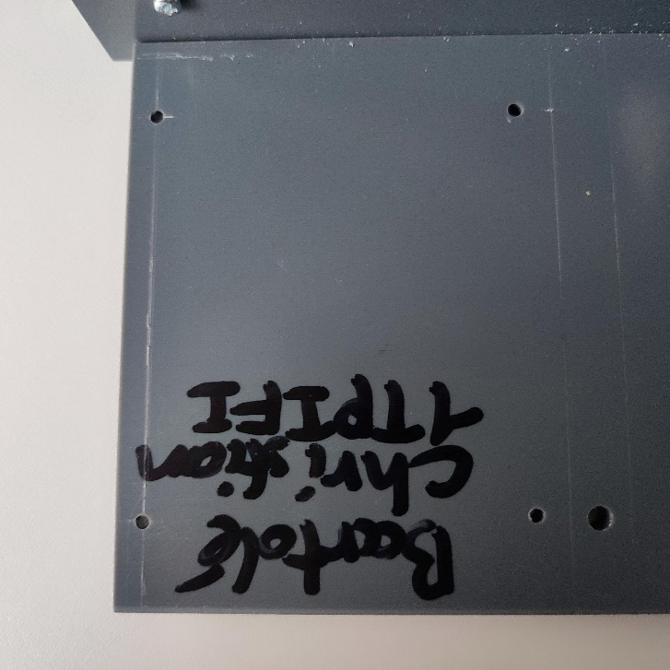
Here how the raspberrypi is connected to the plate. In addition to the 4 screws it also has for each a washer, a nut & a 5mm space sleeve between the PI & the plate.:
(NOTE: Due to 1-2mm difference between the schematic and the real plate, the screws for screwing the raspberrypi had to be screwed into the plate a bit sideways.)
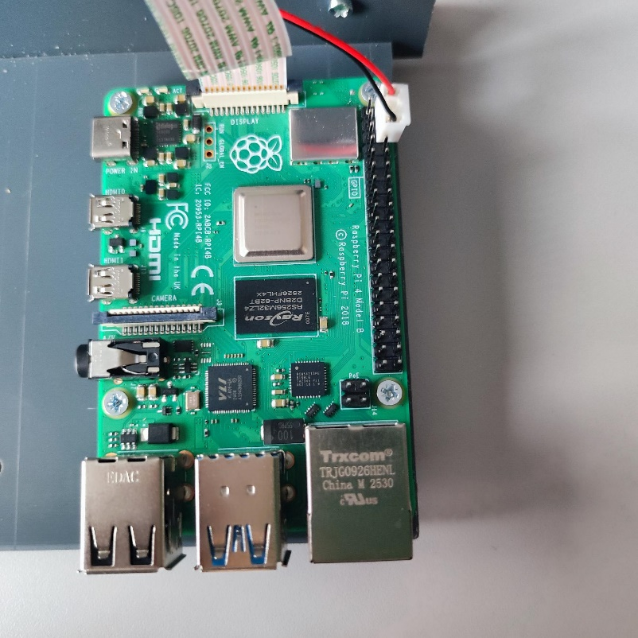
Before connecting both plates the base plate needed 3 holes on the top part of the plate drilled with 2.3mm & an M3 drill afterwards for the screws.

Plate assembly
Now that both plates are prepared, connect both together with M3 screws provided.
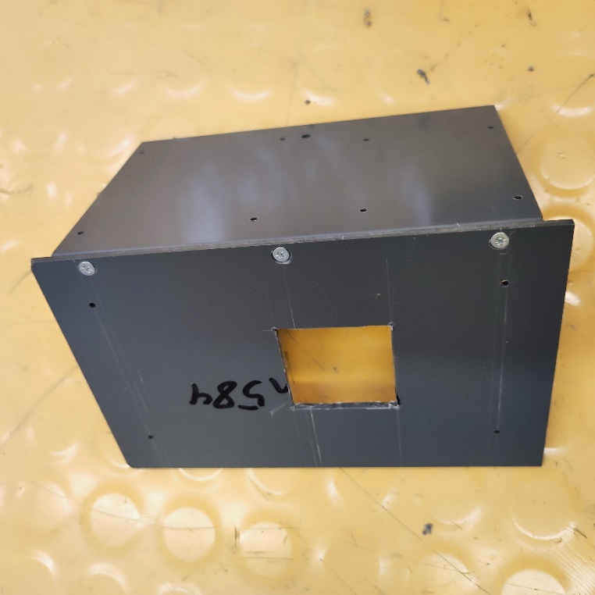
And now it looks something like this:
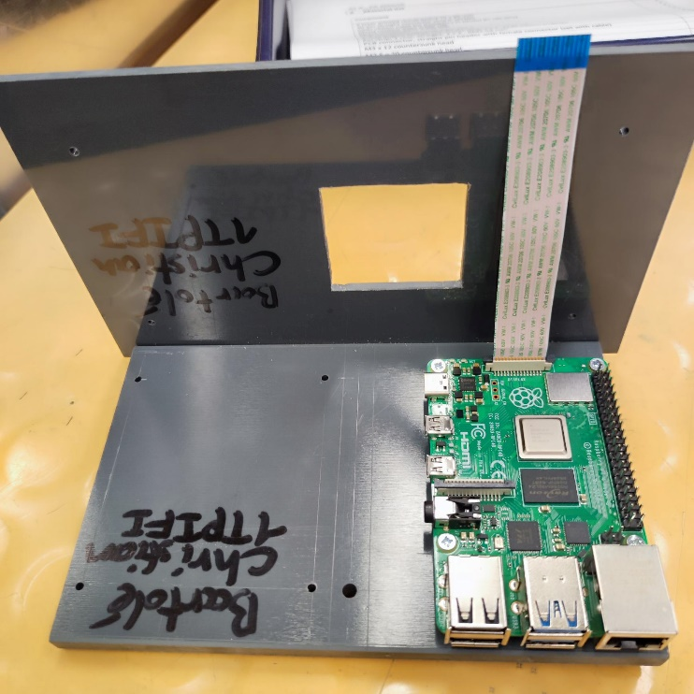

The next thing put onto was the display with the 4 screws earlier created more to the corner of the display plate like so with the displays threaded holes with some 5mm black spacers in between:
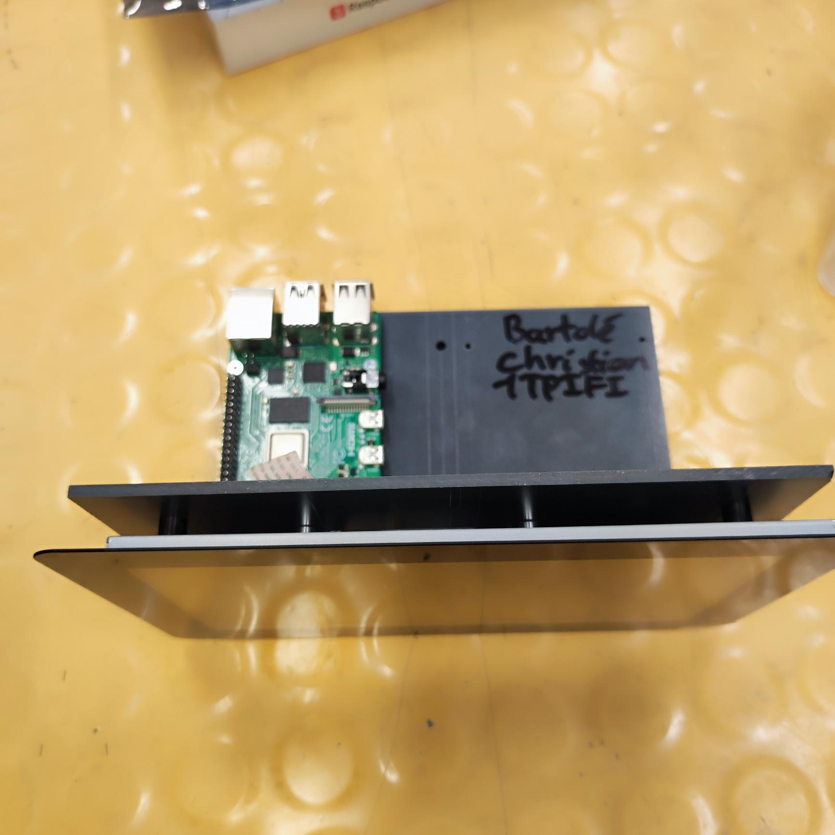
NOTE: due to a difference of 1-2mm 1 screw did not go into the threaded insert and had to be left unconnected by attaching the screw inside with a spacer and a nut.

Now the necessary cables (DISPLAY & power cable for the display are connected to the raspberrypi). The red pin on a a 5V pin & the black on a GND pin on the PI and the cable connected to the JST connector labeled DISPLAY)
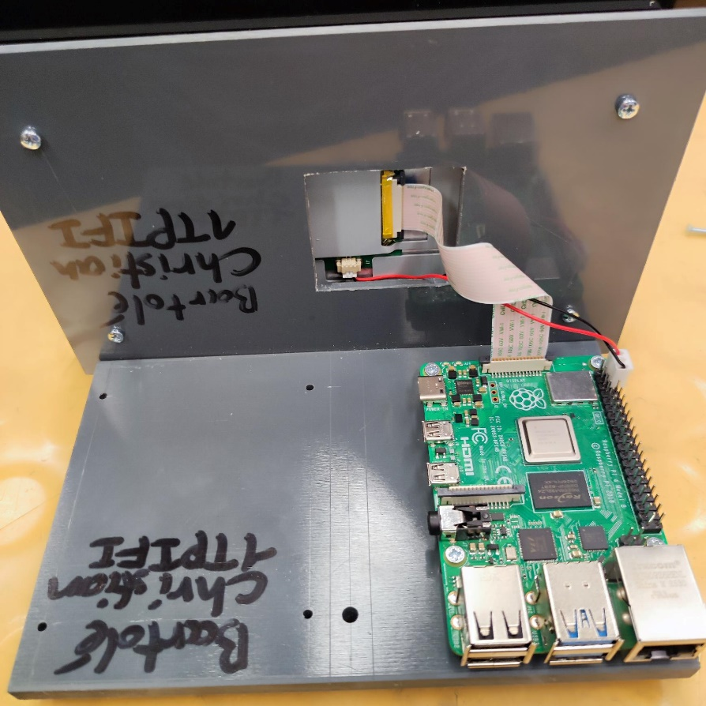
Last step was to add some feets to the bottom of the base plate:
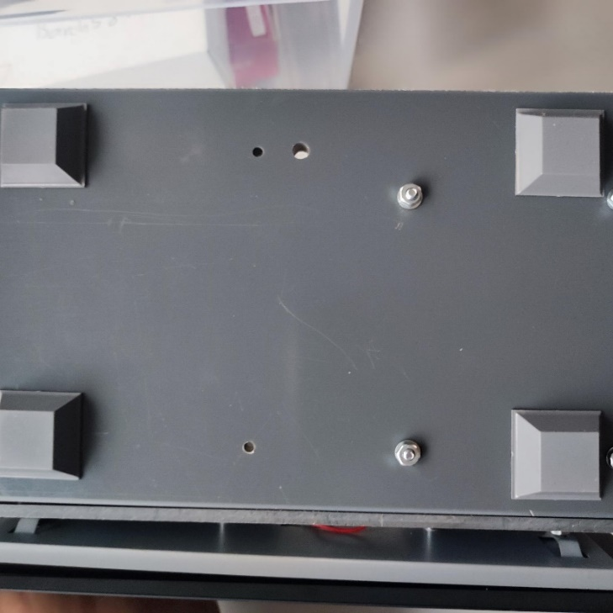
And with all of these steps the basic construction is finished now.

PCB assembly

Check that all your components are present and are correct according to the material list:
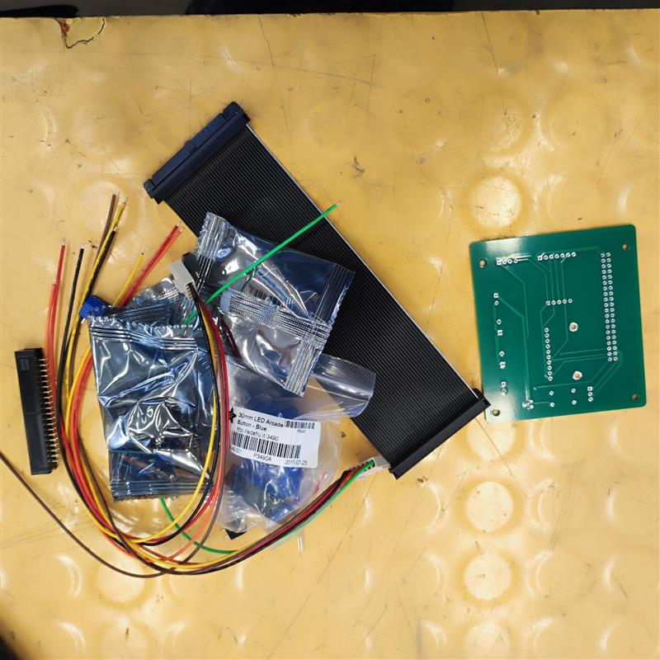

Always start with soldering the smallest components. In this case it starts therefore with resistors & the screw mount terminal blocks.
NOTE: Double check that the resistance of the resistors matches the schematics resistance. It is strongly recommended to check this with a multimeter.
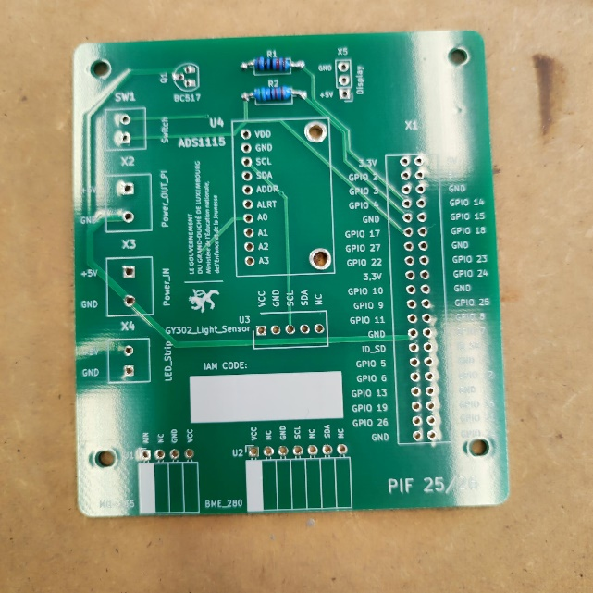

For the screw mounting terminals make sure that the intake holes for the cables are facing outwards & that the sizes match the footprints on the pcb.
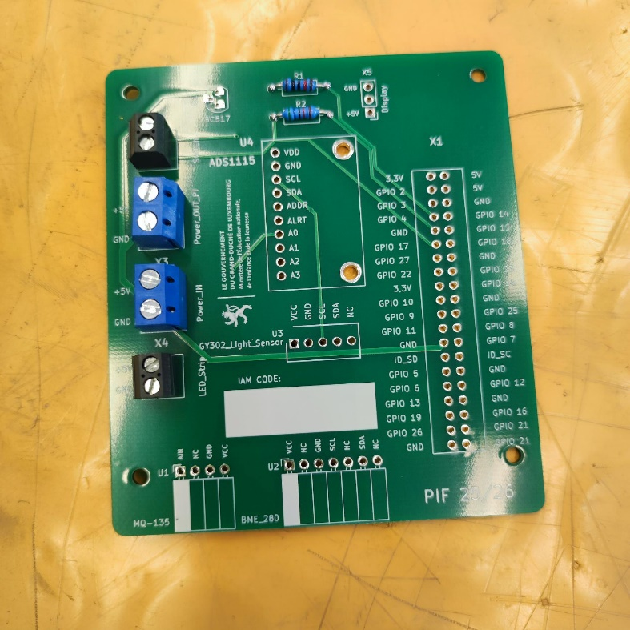

The next step is to solder both JST connectors. You may notice that the connector for U2 or MBE280 do not match the pin number of the connector. Make sure that the pin NC (Not connected) on the U2 value does not have a pin and that VCC gets this pin. The orientation of both jst connectors must face to the “south” of the board like shown in the picture. Lastly make sure that for the transistor soldered onto the pcb the flat side on the back of the component matches the pcb’s footprint
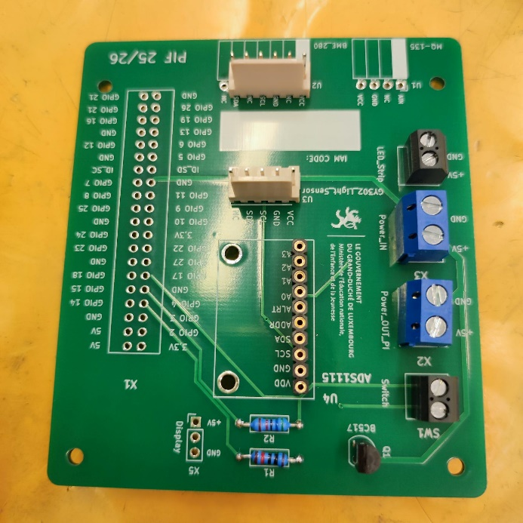

Now for the ADS1115 solder it to the pinheader provided in the package, solder the pin socket on the right place, push it into the socket and make sure everything is straight.
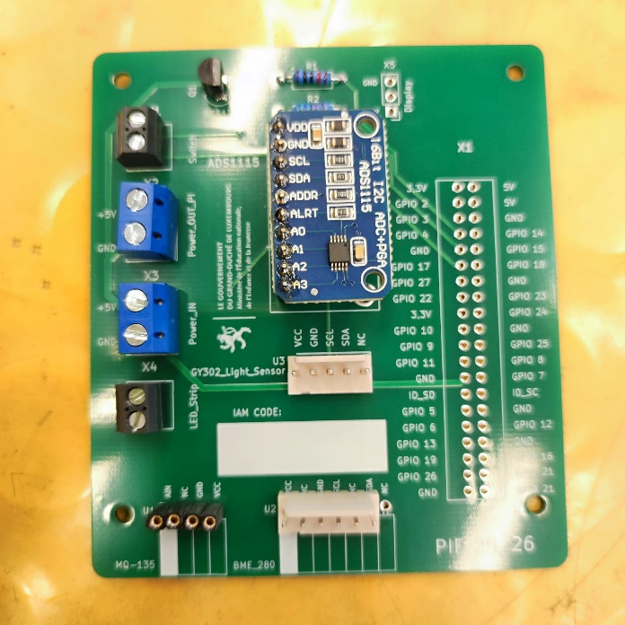

Now solder the last components which is a 3 pin header for the display, a 4 pin socket for the MQ-135 & a 40 pin header for the GPIO pins of the raspberry pi. You may notice that the 40 pin header has a tiny hole on one side of the connector in the middle. This hole must face inwards in the pcb like shown in the photo.
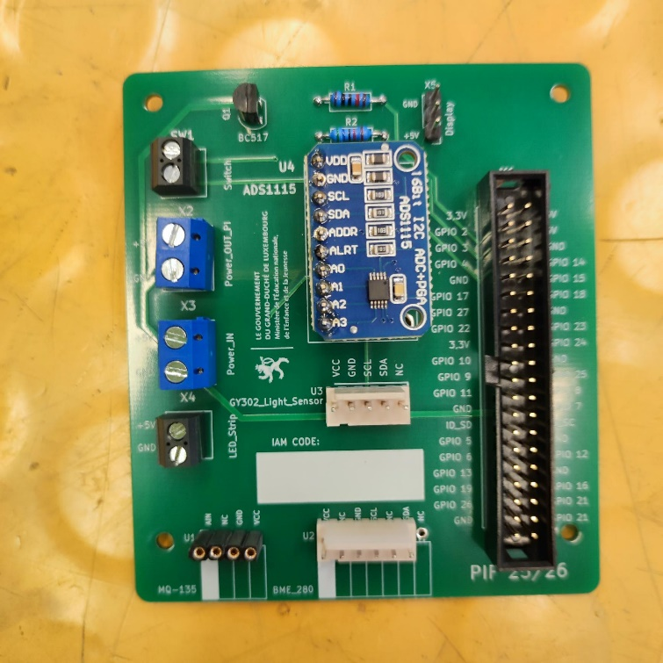

PVC plates assembly

Before mounting it don’t forget to write your IAM code in the blank part where it is written IAM CODE:
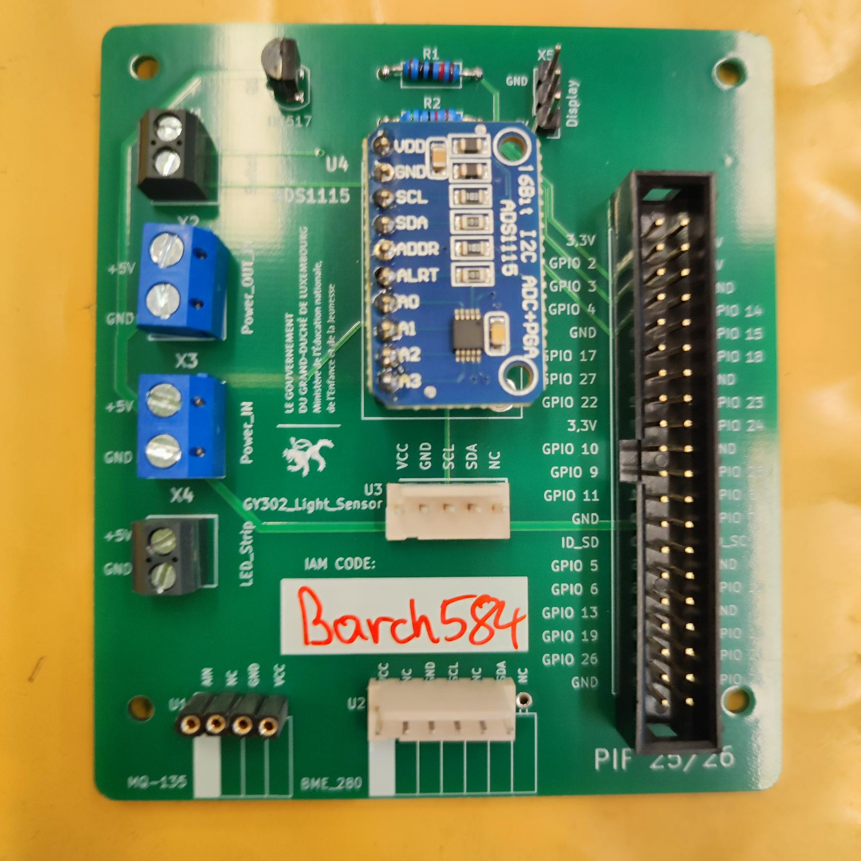
You can also connect all the for the moment available cables onto it for the moment:
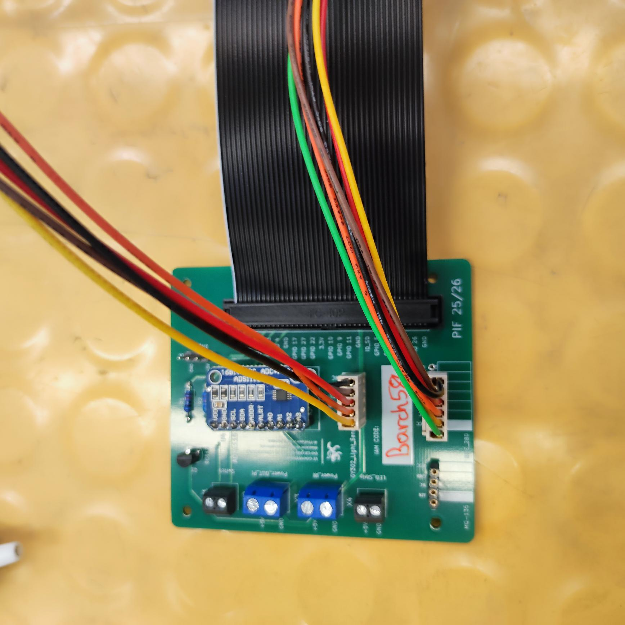

The next thing to do is to screw it onto the base PVC plate into the appriopriate drilled holes drilled earlier and use some M2.5 screws with a washer & on top of the washer a nut on each one.
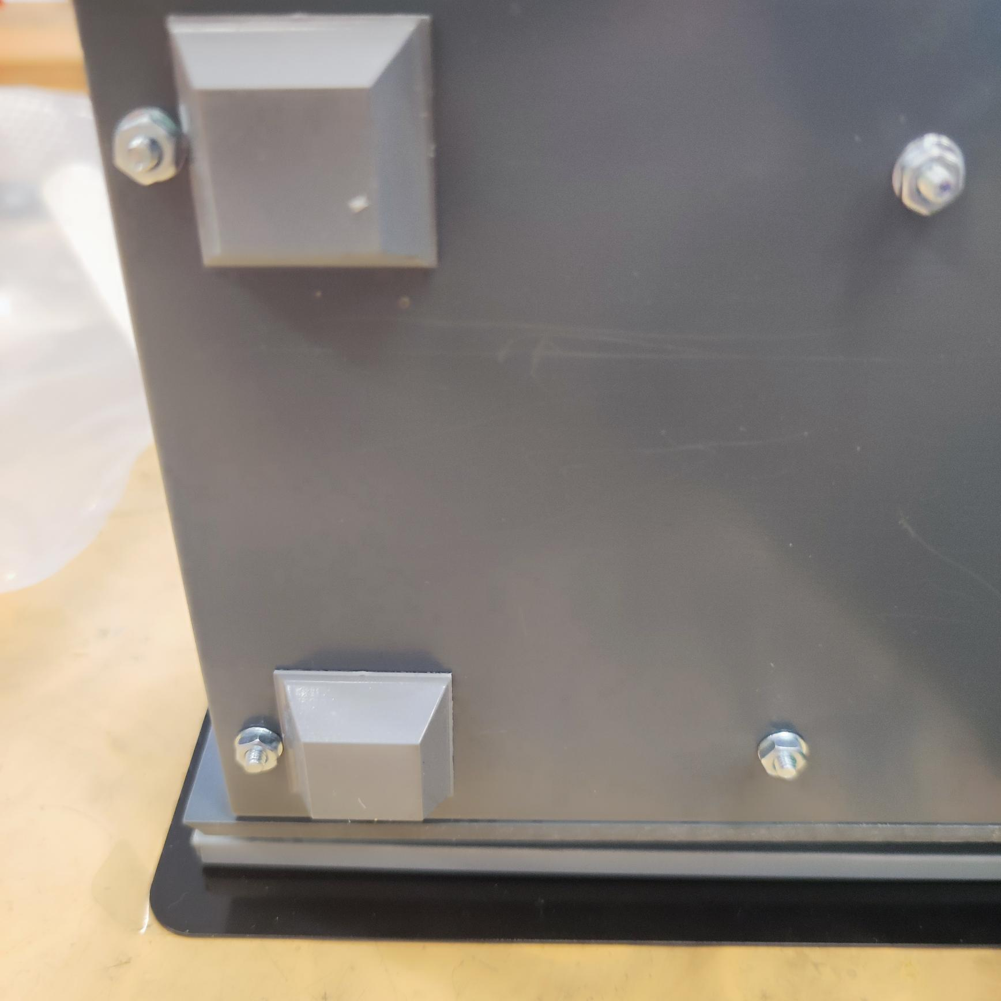

Now connect the big ribbon cable to the raspberry pi & reconnect the display’s cable to the pin header on the top right of the PCB where it is written Display
To test that everything works plug in the UBC-C PSU as well.
NOTE: It is highly recommend to disconnect the JST cables to prevent any short circuits as the cables from the connector can short together as they do not have an insulation right know.
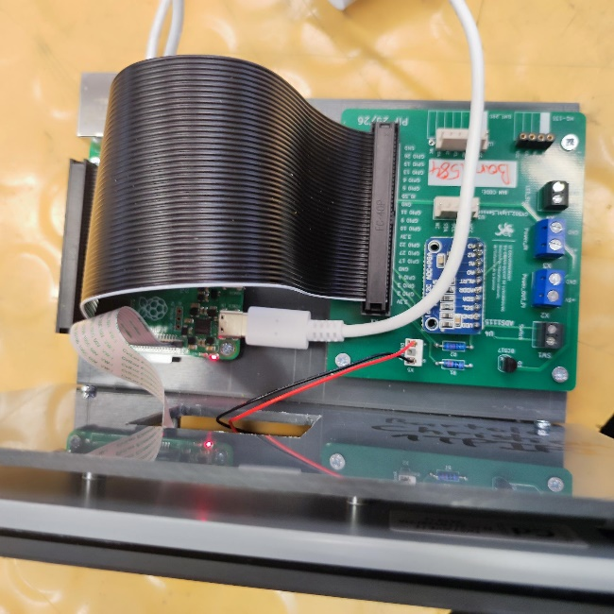

It should now turn on everything when providing electricity.
NOTE: The connector for the power of the display has pretty loose pins which means that you MAY have to adjust the connector on the pin header a bit with your fingers to get the display working
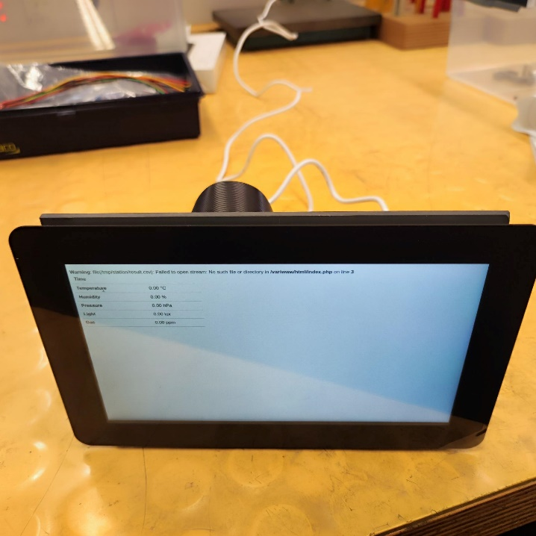
After disconnecting the power you can also replug the JST cables back into their corresponding JST pin headers.
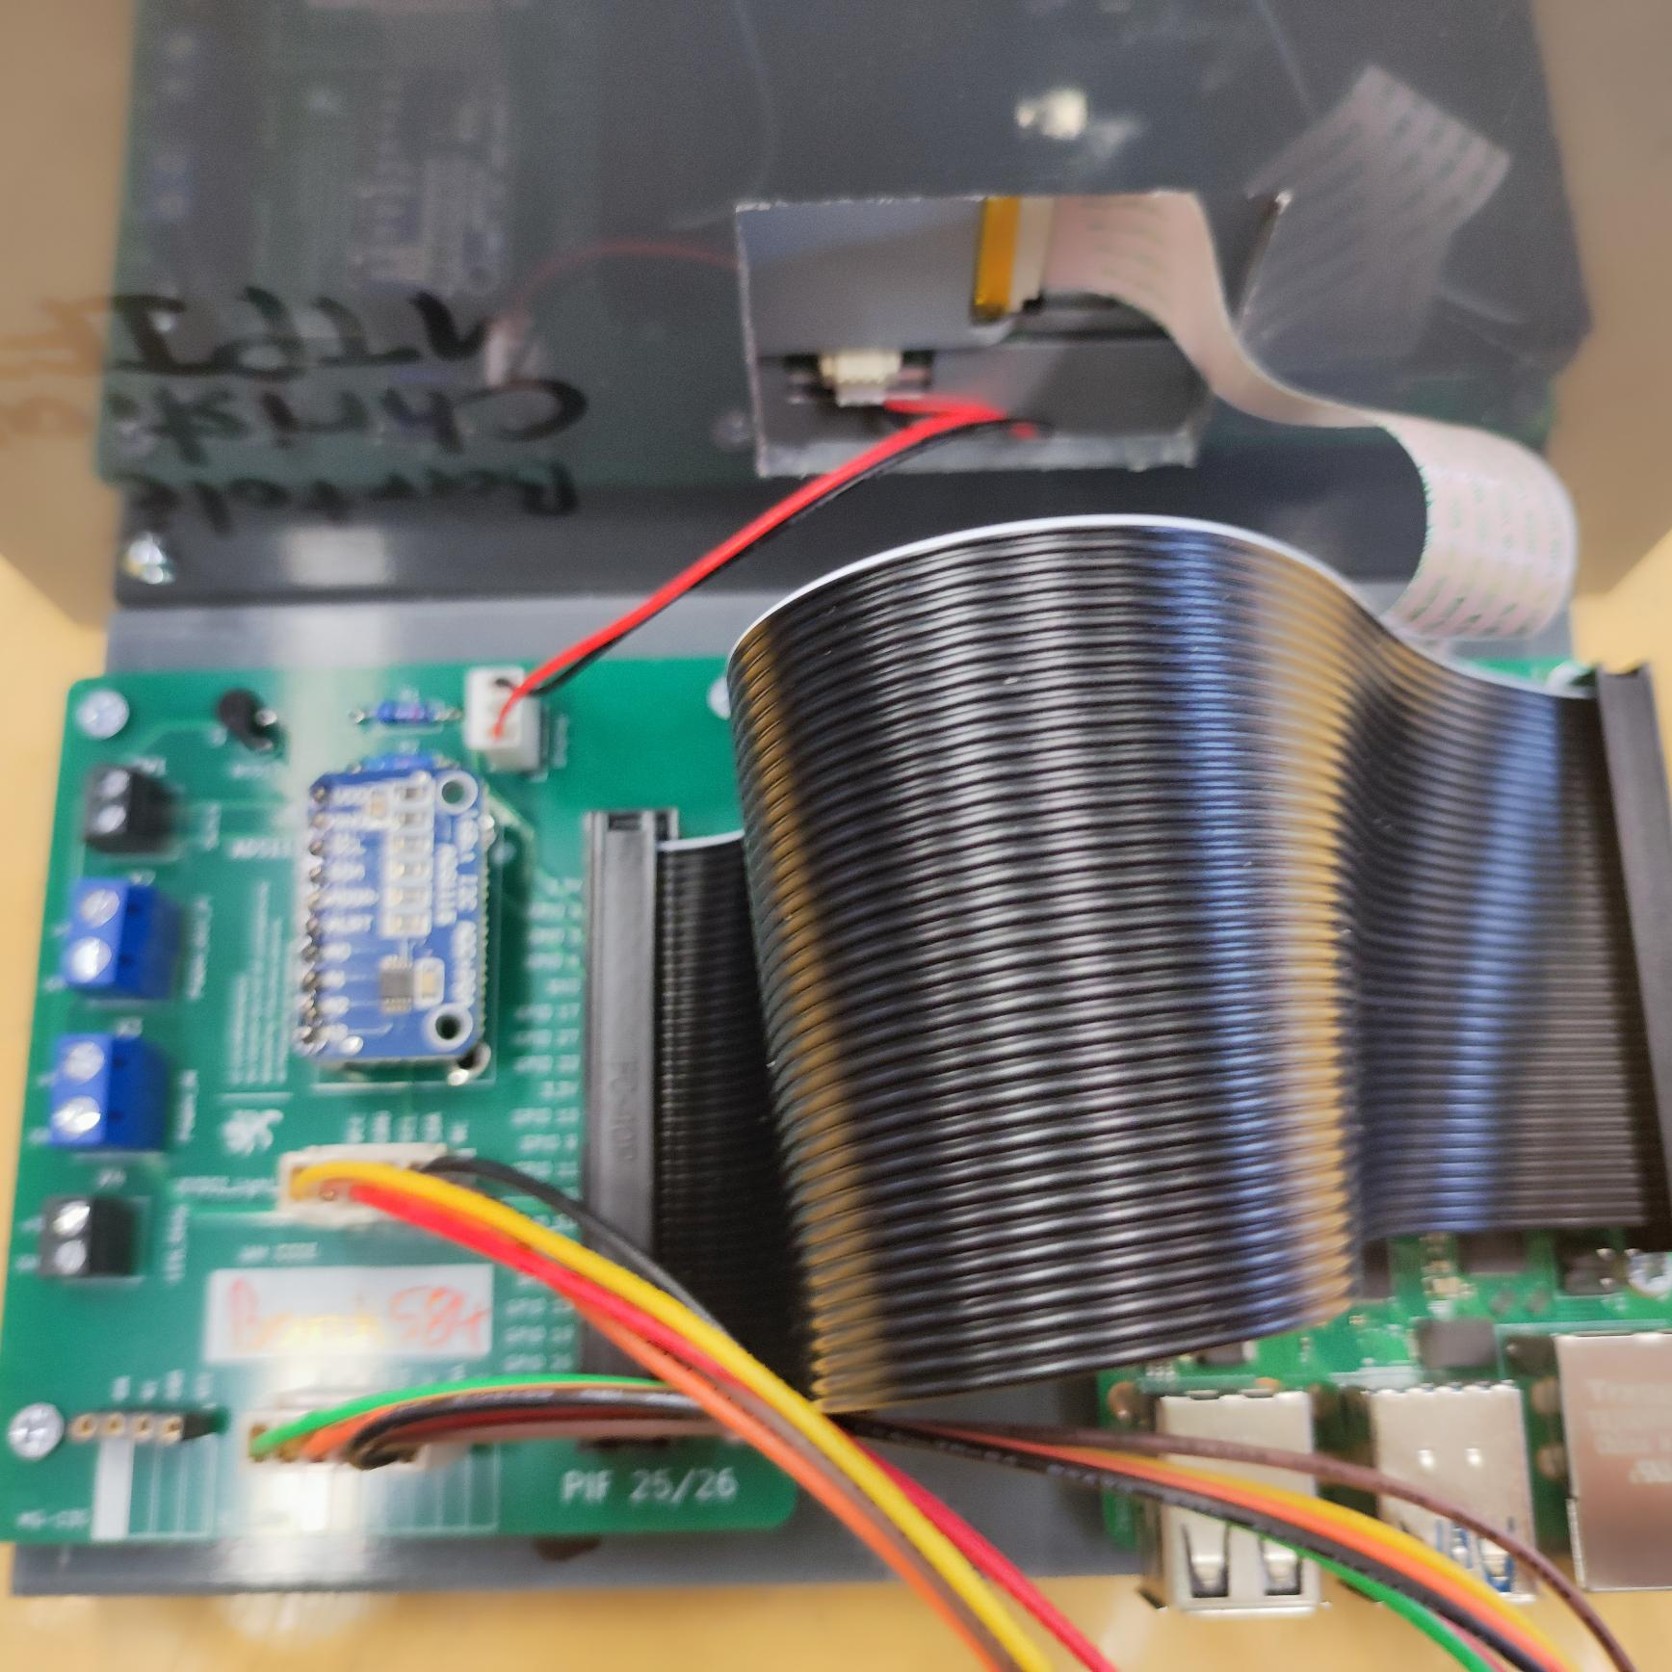
And after all of that the pcb is complete

Cable repair

Starting note:
This documentation will not be about repairing a raspberry pi cable but about a generic cable repair that can be used for practically almost any cable. Almost all the steps for a raspberry PI cable repair are the same. This documentation will cover removing a cable insulation, wire stripping and connecting the wires all back together with proper insulation with a soldering iron and a heat gun.

Uninsulate wires
We’ll start off with a simple wire like this one:
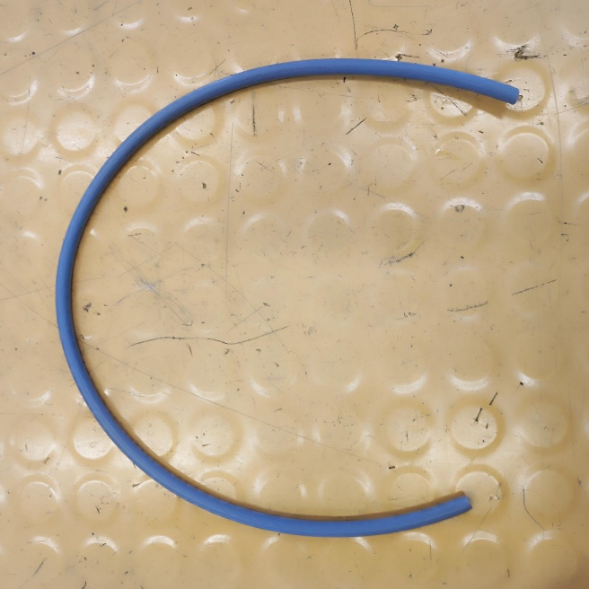
And we will cut it in half to about the same size on each end:
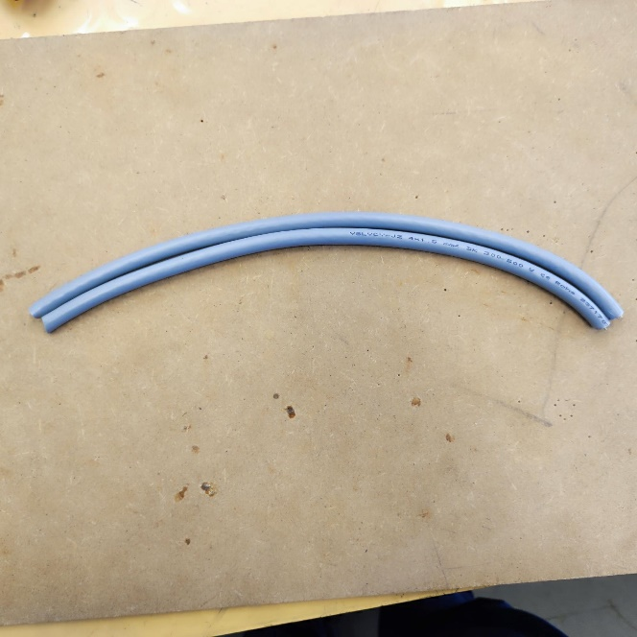

Next step is to uninsulate the cable. Make sure that you do not damage the wires while cutting in the rubber layer keeping all wires together. There are many tools to do this, but the most commons are a wire stripping knife or a rotary wire stripper Take all the shield of the cable, “group” it together and twist it to get from this:
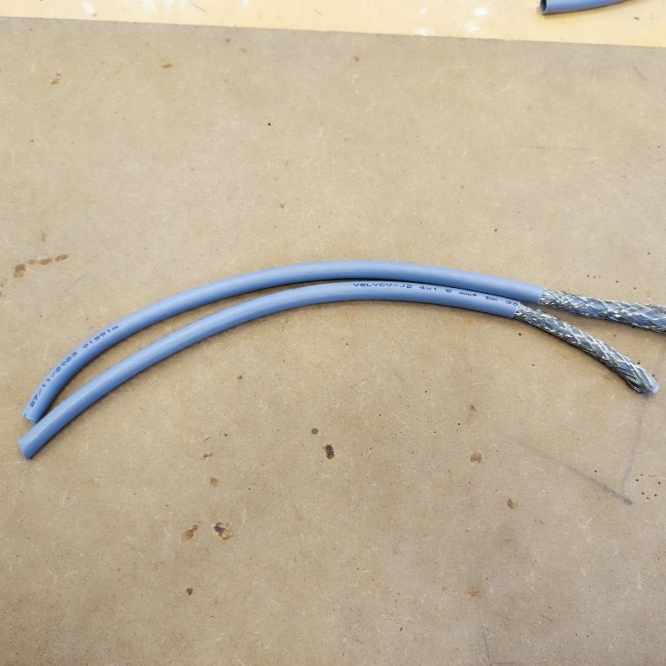
To this:
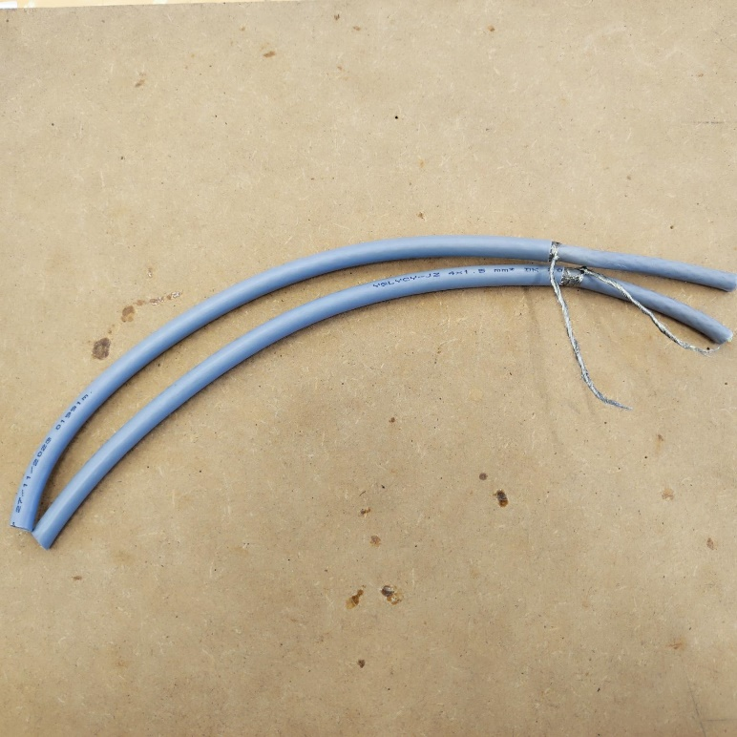
There is in this cable one more insulating rubber layer which also needs to be taken off to get to the individual cables like shown below:
NOTE: a lot of cables only have one rubber layer and then already the individual wires and some also do not even have a shielding. This heavely depends on the cable you use so depending on that some steps do not need to be made.
In this cable there is one more rubber insulation under the shield which leads to the actual individual wires. Again, while taking the insulation of make sure that you do not damage any wire.
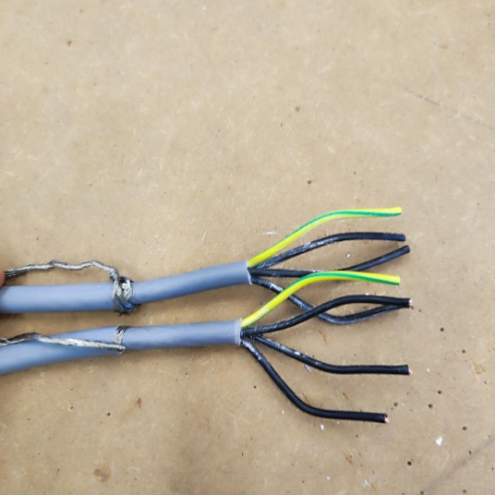

Wire stripping
Afterwards to continue the repair use a wire stripper (again) to expose the metal of each cable like in the photo below. Make sure that you destroy the least of those “tiny” metal cables as possible as this can easily happen with the wire stripper if too much force is applied.
Also staggering them like in the photo below, where you can e.g. see that both wires of the earth do not have the same length to improve the cables stability overall. This must be done for each one of course and as noticed each one should have a different length on both ends.
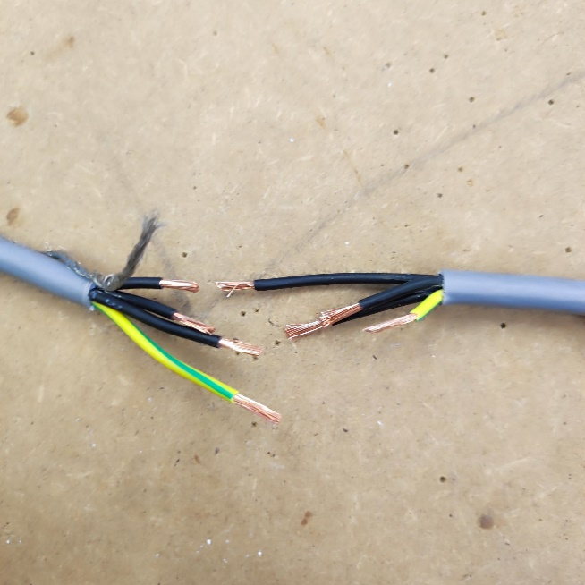

Connect each wire back together
Now to get the wires back together twist the ends of the exposed wires to get it more compact and apply enough solder to each end:
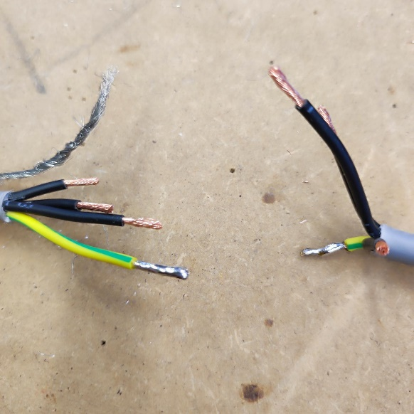
Before soldering & thereby connecting everything with the soldering iron, get the insulation already on each wire. After which put the insulating part enough to one end so it does not burn under the soldering iron. This process must of course be repeated for each individual wire.
NOTE: Make sure to use max heat (usually around 480-500°C) and take enough time to get a sturdy connection
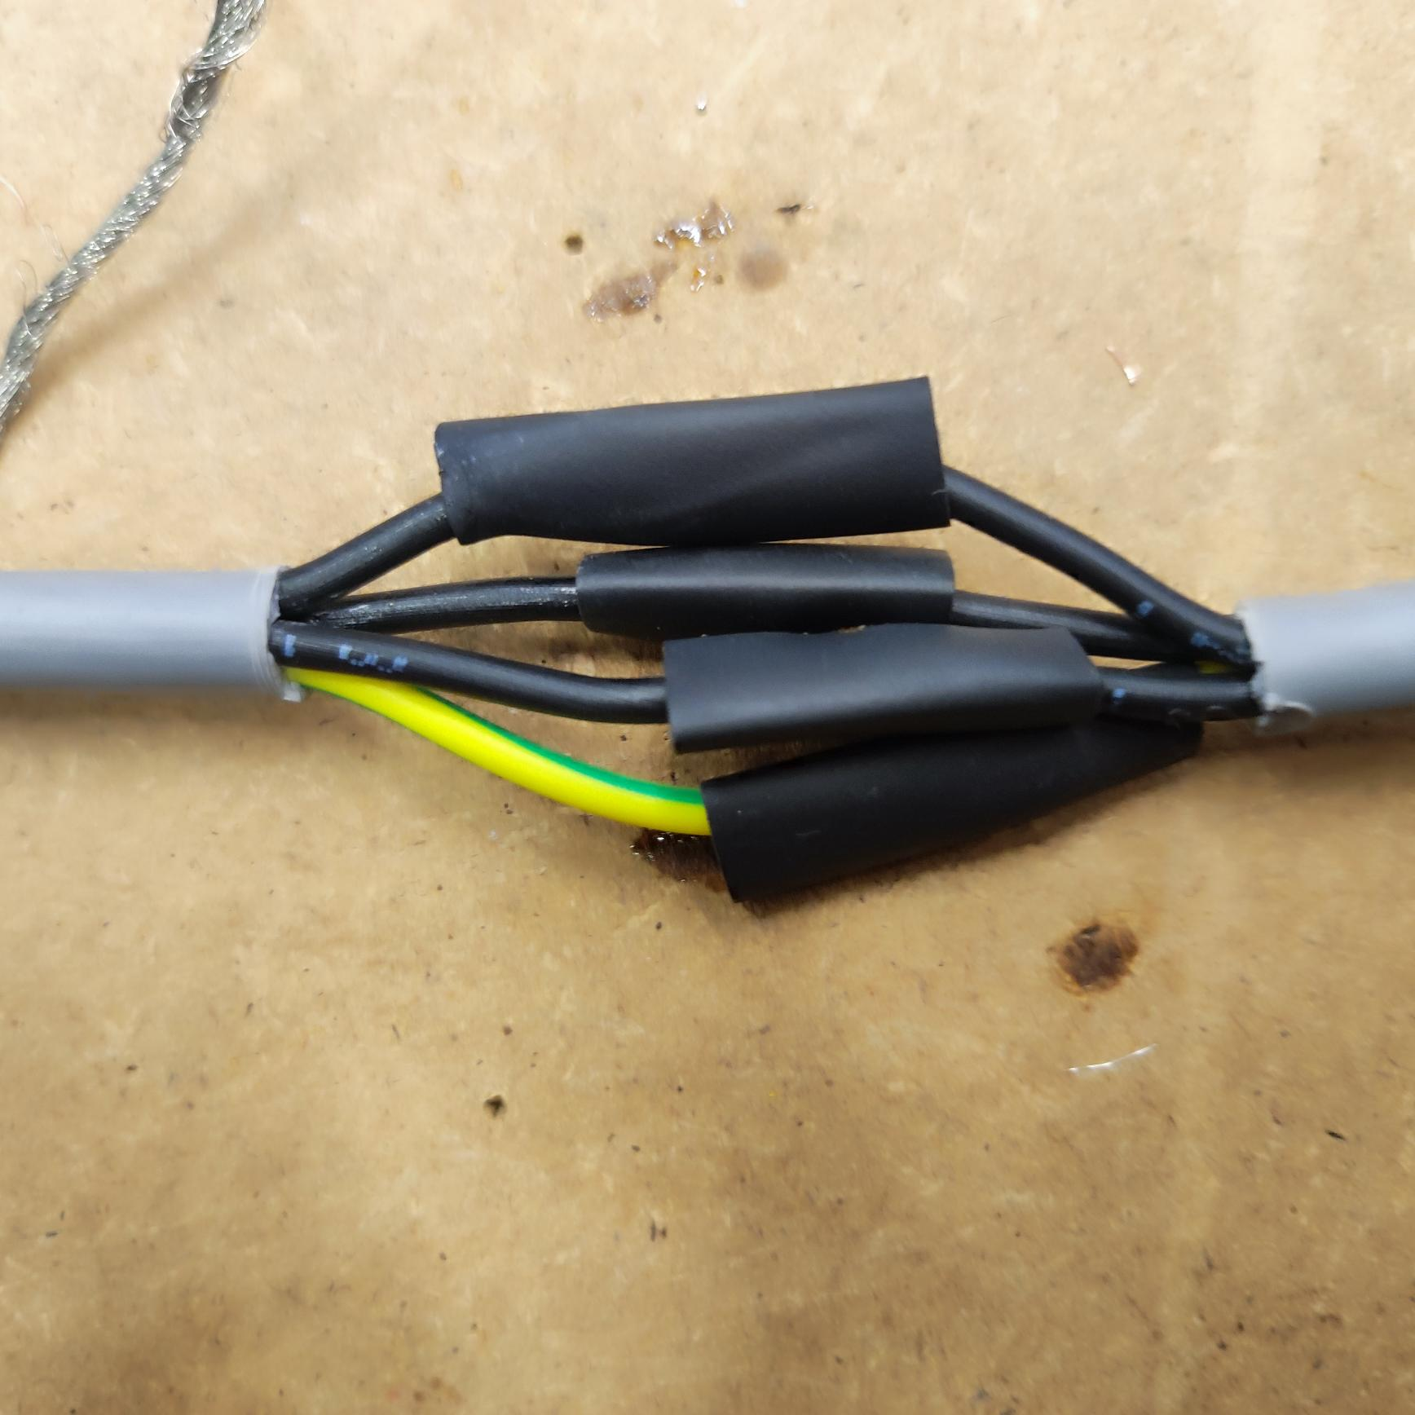

Cable insulation
Next get the cable insulation for the cable over the cable and make sure everything is covered in it and no end of any wire is exposed. Afterwards apply heat with a heat gun and your cables are connected securely.
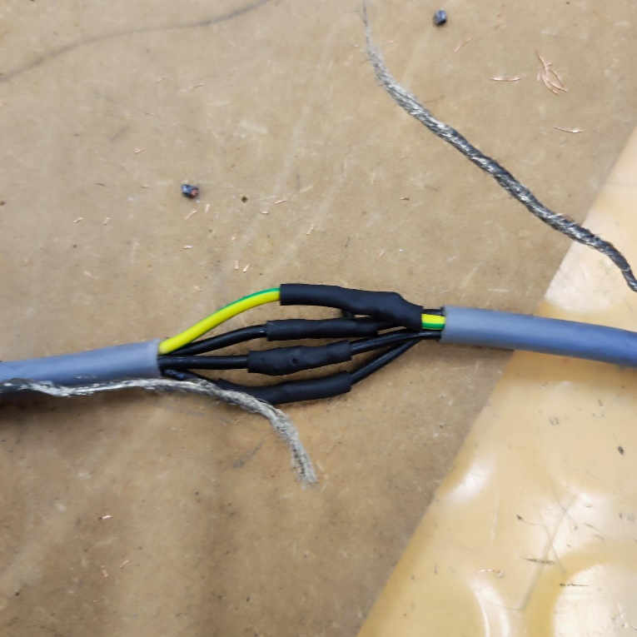

Shielding tips
Of course, do not forget to repeat the moves for the earth as well. For the earth I highly recommend twisting both ends together to make the repair much easier, when soldering afterwards and do not forget to put an insulation for it on there as well.
NOTE: you should use a longer piece of cable insulation so that even if one cable is not properly insulated, it does not interfere directly with the shielding.
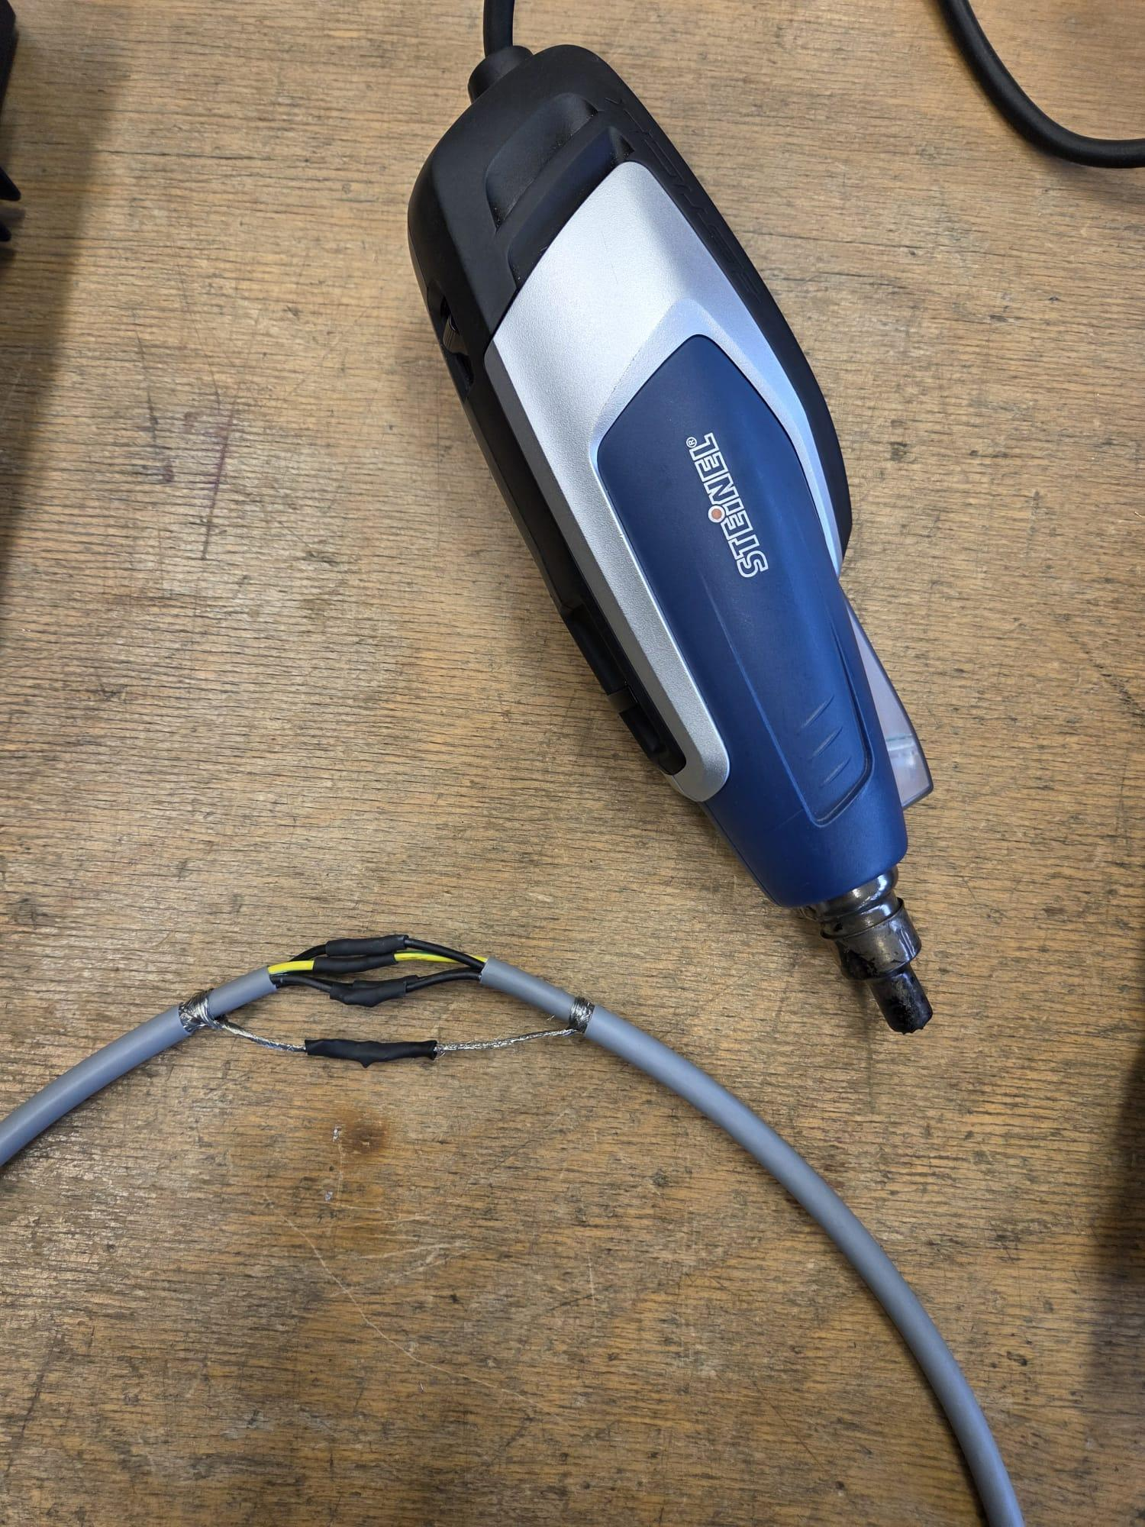

Sensors 1

Gas sensor
Take out the gas sensor and check for
Take out the gas sensor and check for the pinout on the component and the pcb.
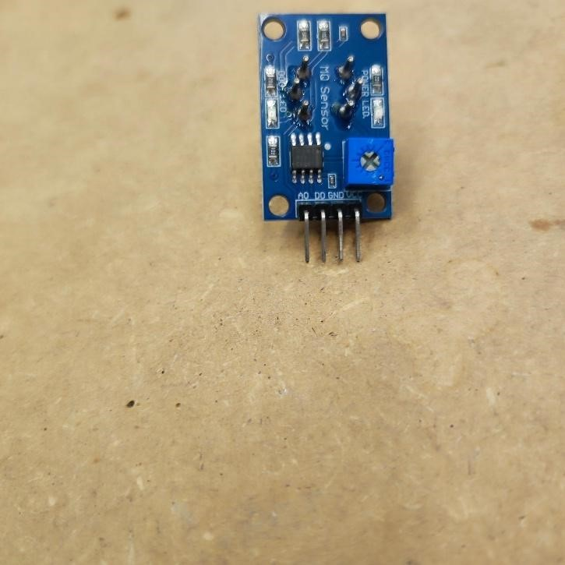
Afterwards plug it in according to the pins on the PCB. The sensor must face inwards like shown in the photo:

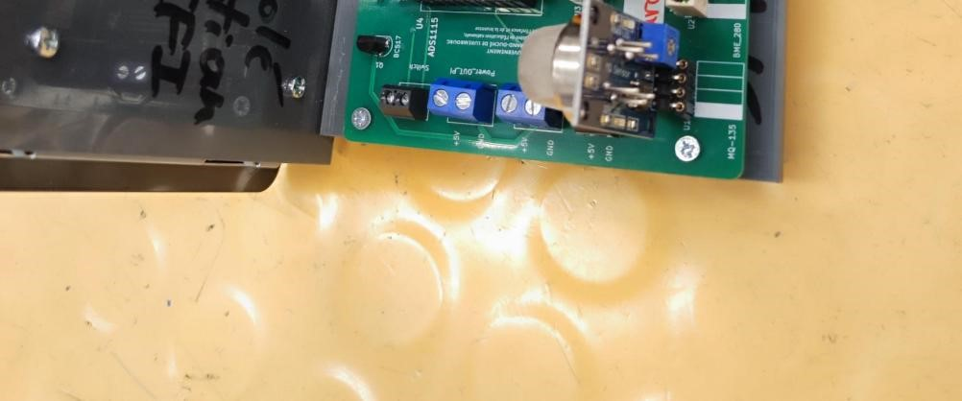

Bit I2C converter
Now for the 16-bit i2c converter simply solder the pinheader to the component like shown in the photo below:
NOTE: Make sure that the pinheaders are straight. This can be achieved by starting to solder 1 pin and if it is not straight, go over it with soldering iron and straighten it. Afterwards proceed with soldering the remaining pins.
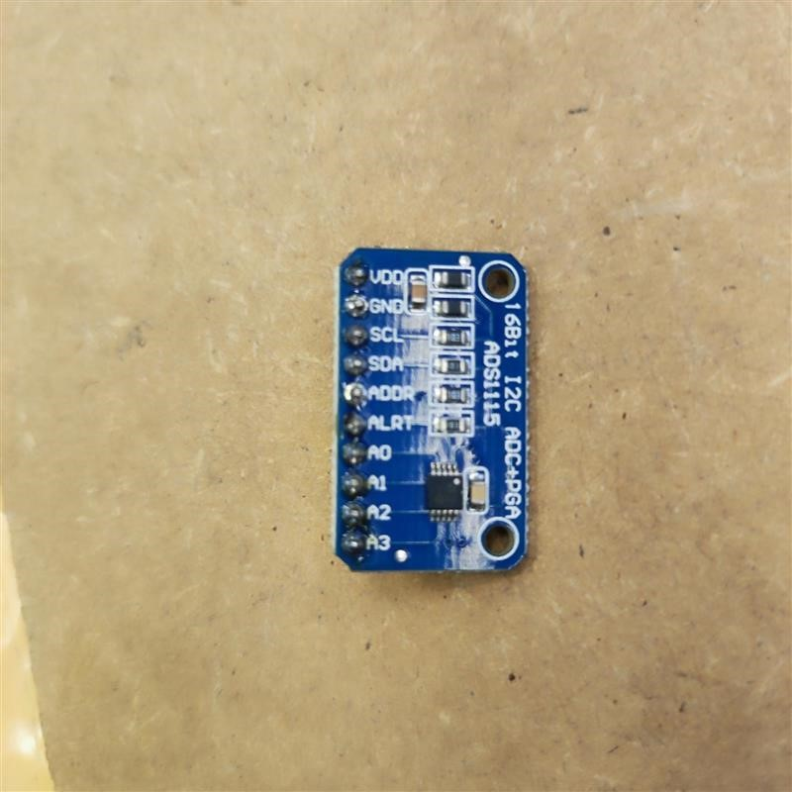
Now plug it into the right slot on the pcb with the pinout matching on both sides (PCB & the component).
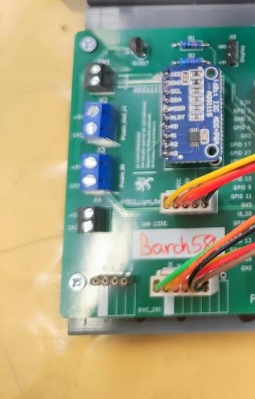

Sensors 2

Biometric sensor
Take out the biometric sensor (HW-611) and check for the pinout on the component and the pcb. Afterwards solder the wires to the pins according to the schematic.
Make sure you take the right connector as both are different in number of pins (for this one you need the 6 pin connector, including NC)
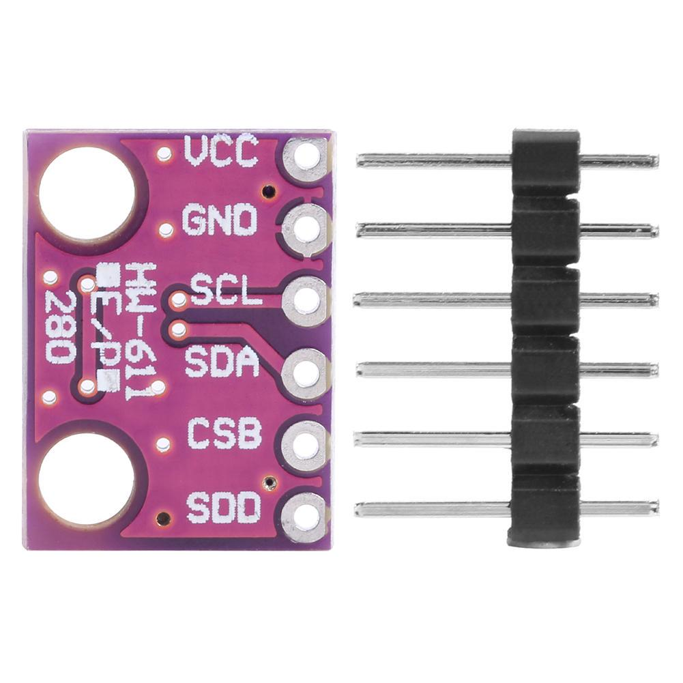¹
Black wire -> VCC
Red wire -> GND
Orange wire -> SCL
Green wire -> SDA
CSB & SDD are not in use and can be left unconnected. The two (2) wires (which are brown and yellow should be cut to the same length with a wire cutter the to only expose the end of both wires. Next, take a piece of wire insulation and stick it over both wires. Lastly heat it (with e.g. a heating gun) and crimp them together with a gripper (or any other crimping tool that works for this case).
Make sure to not solder any pin on the component to NC as this is simply Not Connected to anything.

Gyroscope sensor
Now for the gyroscope sensor (GY-302), take it out and check for the pinout on the component and the pcb. Afterwards solder the wires to the pins according to the schematic.
Make sure you take the right connector as both are different in number of pins (for this one you need the 5 pin connector, including NC)

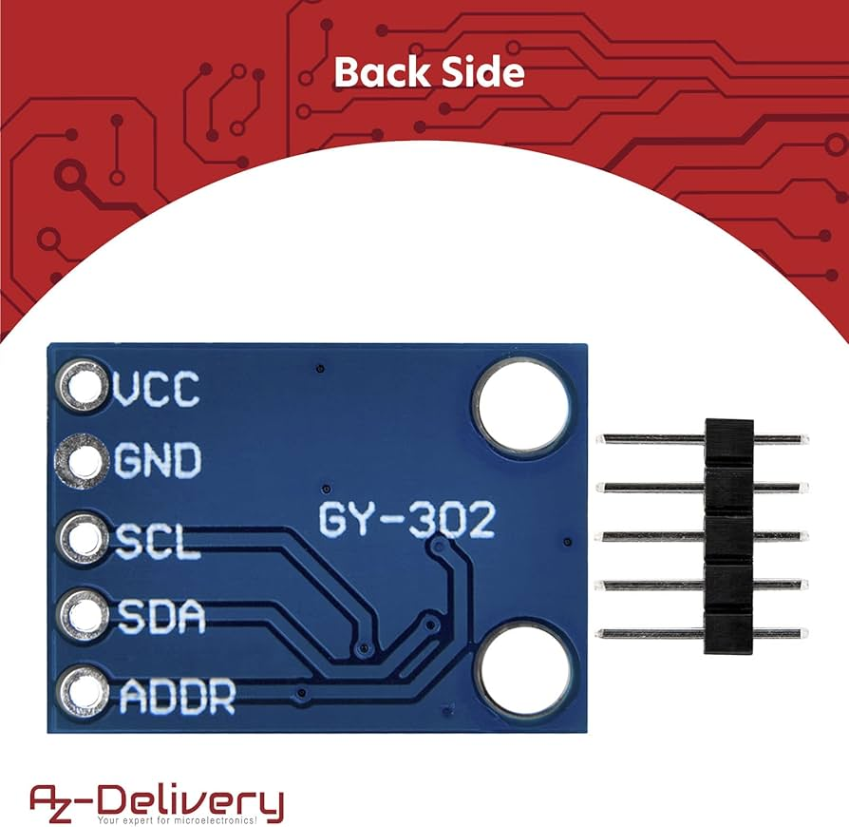²

Black wire -> VCC
Brown wire -> GND
Red wire -> SCL
Orange wire -> SDA
Yellow wire -> ADDR

Sensor programming (BME280 / HW-611)

First start by installing python with sudo apt install python3-venv python3-full python3-vnv

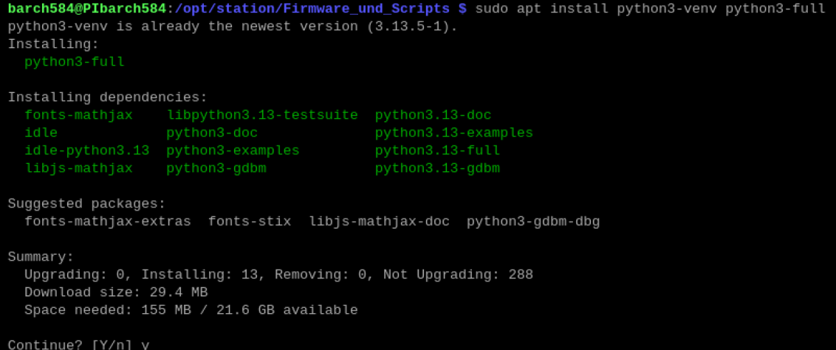

Next navigate to /opt/station with cd /opt/station and run python3 -m venv venv
Activate the venv mode with source venv/bin/activate.
Afterwards install the extra needed python libraries for i2c devices, for which the command sudo apt install -y python3-smbus i2c-tools is needed

Next, install the library for the bmp280 for which simply run pip install bmp280. Also ensure to install for bme280 with pip install bme280, as this at least for me created problems without it during testing.
If the previous command does not work (due to permission errors) follow this:
Go to /opt with cd /opt and give yourself ownership of /station to be able to have writing permissions to avoid permission errors. For that type in sudo chown -R YOURUSERNAME:root station/ which would be in my case sudo chown -R barch584:root station/
After successfully installing the libraries modify the test-bmp280.py in the firmware & scripts folder with the following:

Source code:
from bmp280 import BMP280
from smbus2 import SMBus
import time

ADDRESS = 0x76

def main():
bus = SMBus(1)
sensor = BMP280(i2c_dev=bus, i2c_addr=ADDRESS)

while True:
temperature = sensor.get_temperature()
pressure = sensor.get_pressure()

print(f"Temperature: {temperature:.2f} °C")
print(f"Pressure: {pressure:.2f} hPa")
print("-" * 30)
time.sleep(2)

if __name__ == "__main__":
main()

NOTE: the ADDRESS variable may be different. To check for the correctly one unplug all the sensors except the barometric sensor and run sudo i2cdetect -y 1 and check for any number in the entire table. (Usually the address for this sensor is 76, but this may change)

Now run the bmp script and you should see measurements:
python3 Firmware_und_scripts/test-bmp280.py

NOTE: I changed the foldername of Firmware und scripts so double check that the folder name in your case is correct.
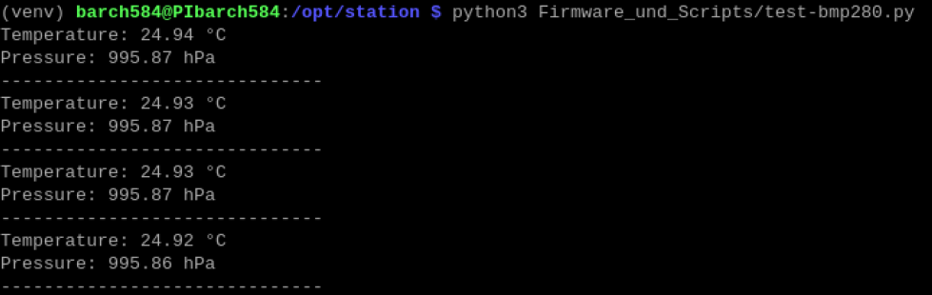

Sensor programming (BH1750)

In your firmware and scripts folder simply start by editing the test-bh1750.py with sudo nano test-bh1750.py and change it to the following code:
import smbus
import time

DEVICE = 0x23 # Your detected address
POWER_ON = 0x01
RESET = 0x07
CONTINUOUS_HIGH_RES_MODE = 0x10

bus = smbus.SMBus(1)

def read_light():
bus.write_byte(DEVICE, POWER_ON)
bus.write_byte(DEVICE, RESET)
bus.write_byte(DEVICE, CONTINUOUS_HIGH_RES_MODE)
time.sleep(0.2)

data = bus.read_i2c_block_data(DEVICE, CONTINUOUS_HIGH_RES_MODE, 2)
result = (data[0] << 8) | data[1]
lux = result / 1.2
return lux

while True:
try:
lux = read_light()
print("Light Level: {:.2f} lux".format(lux))
time.sleep(1)
except Exception as e:
print("Error:", e)
time.sleep(1)

This version has a while loop to get continious values (for the documentation specifically). You may also need to change the i2c address, meaning the value of the variable DEVICE.
Afterwards save it and run it with python3 test-bh1750.py

This value can be manipulated by e.g. putting a finger over the sensor or by holding a torch over the sensor.
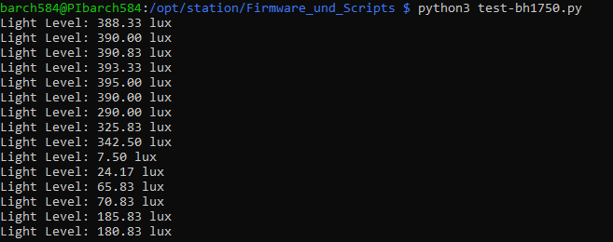

Sources (for sprint Sensors 2):
¹ https:/www.joom.com/de/products/64cf5e1c3899ad01e54e230a
² https://www.amazon.de/AZDelivery-GY-302-BH170-Sensor-Parent/dp/B07TKWNGZ4?th=1

Assembly

Material

Here is everything you will need for this sprint:
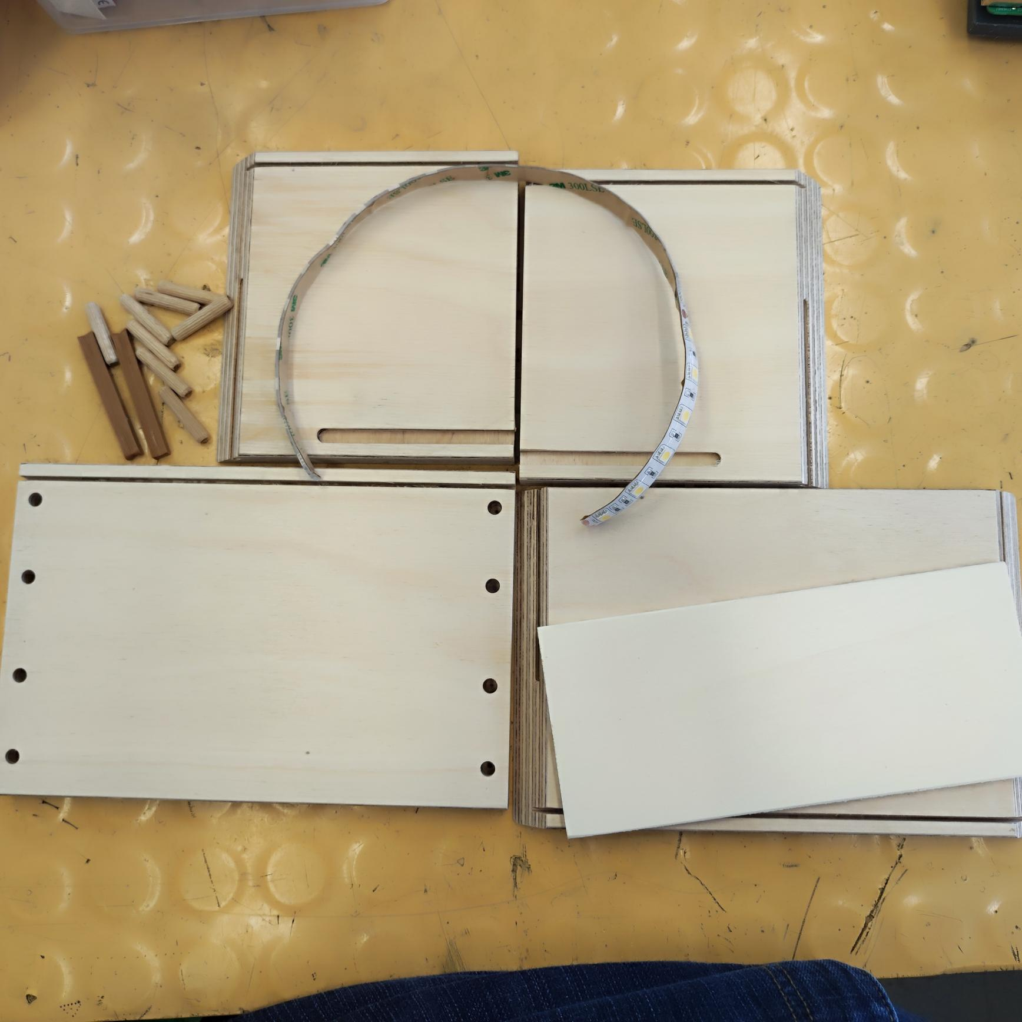

Assembly (wooden box)
Start by getting the base plate and attach these flexible bracket to them. (This might take some force to complete)
NOTE: Pay attention which end goes where. The rounded part of the bracket on the end of it goes inside and the more corner end must face outward:
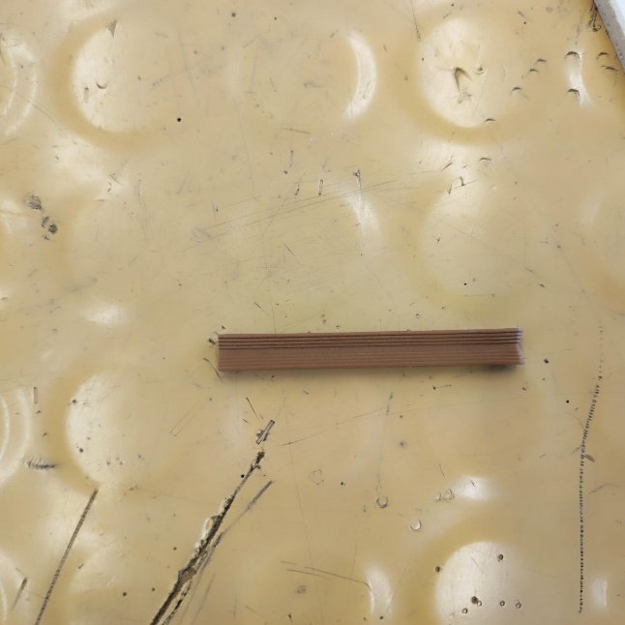
It should look something like this:
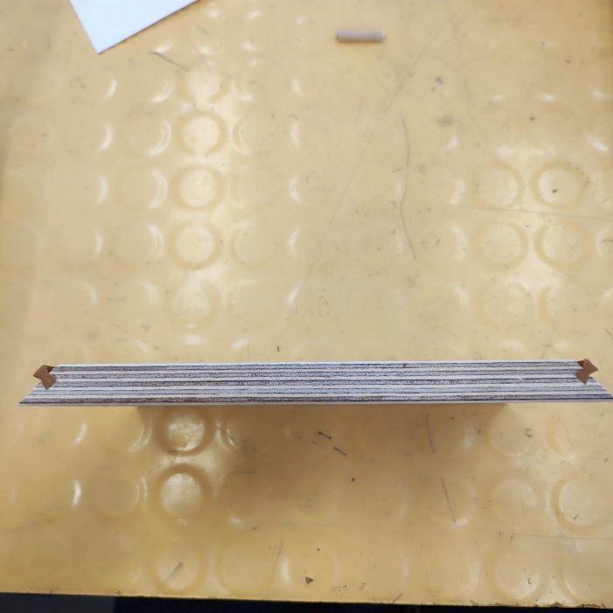

Remove also the feets from the PVC plates and reput them to the bottom part of the wooden box:
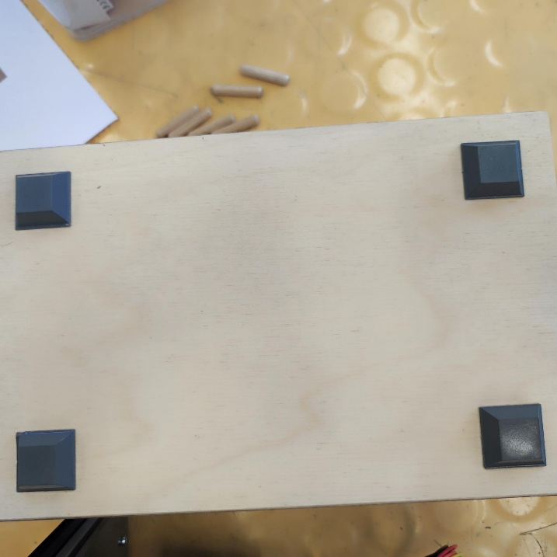
Now slide each side to the brackets on the bottom plate:
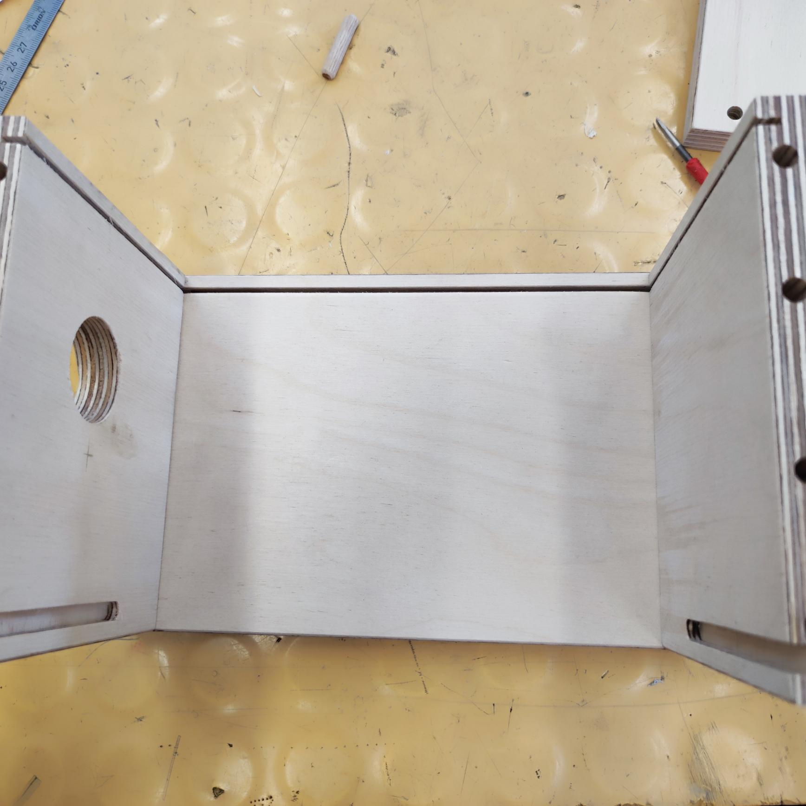

Afterwards put the PVC base with the raspberry PI, the custom pcb with the display together in the box like this:

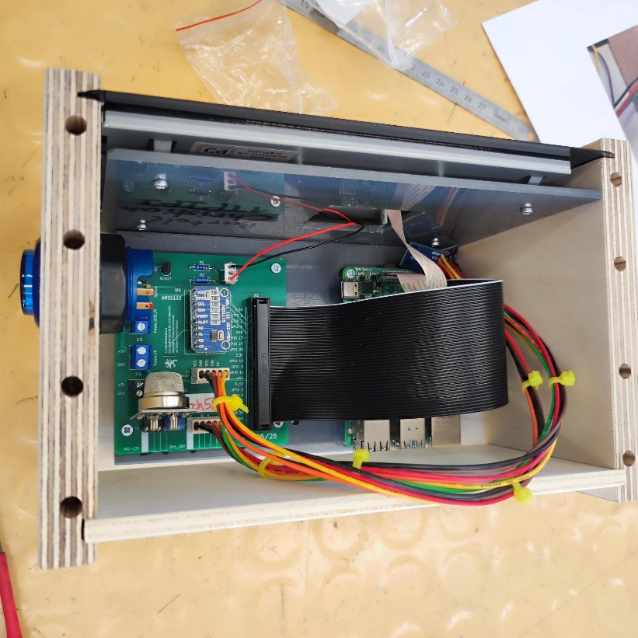
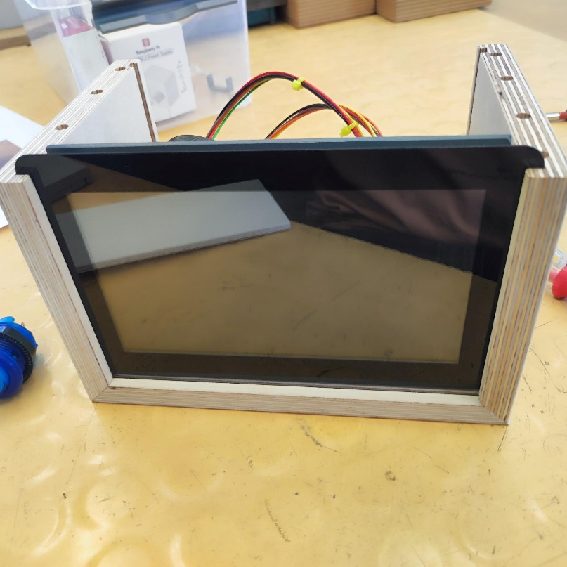

Now for the back plate simply put some holes in it for the sensors.
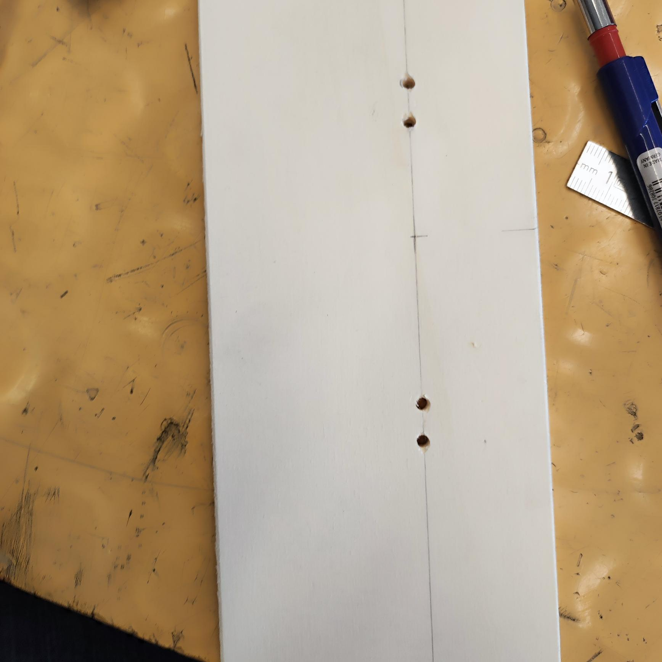
Also don’t forget to screw your sensors to it.

Assembly (button)

For this you need 2 wires (preferably in red & black)
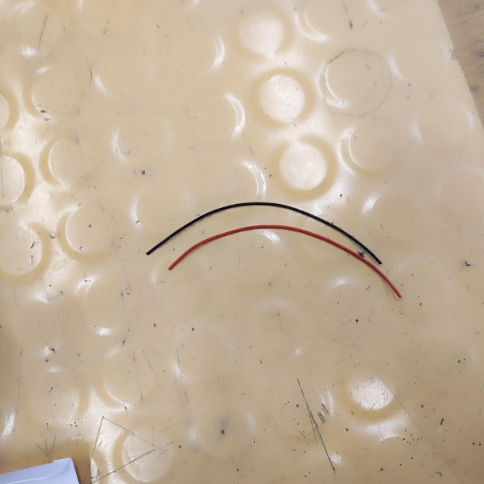
Start by uninsulated each end of them:

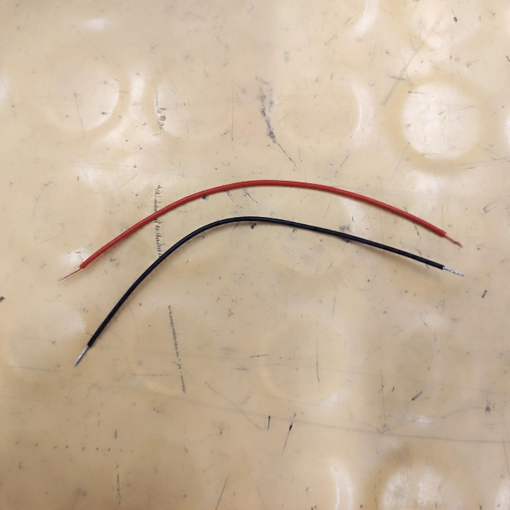

Afterwards make yourself a marking for drilling.
NOTE: If you assembled everything already together you may have to take apart everything to drill this needed hole for the button:
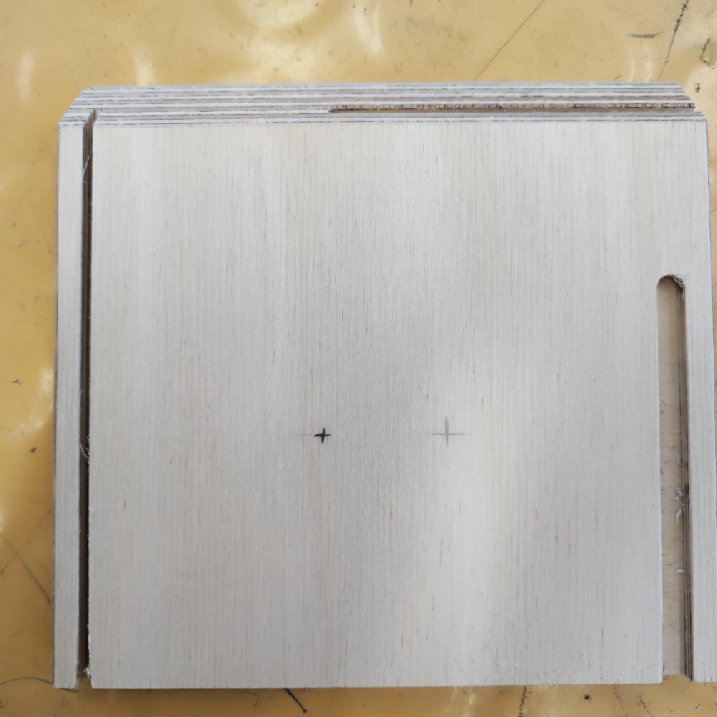
And start by drilling with a step bit to open it up
NOTE: To achieve a better result, it is highly recommended to pre-drill the hole with a smaller drill before drilling with the step bit.
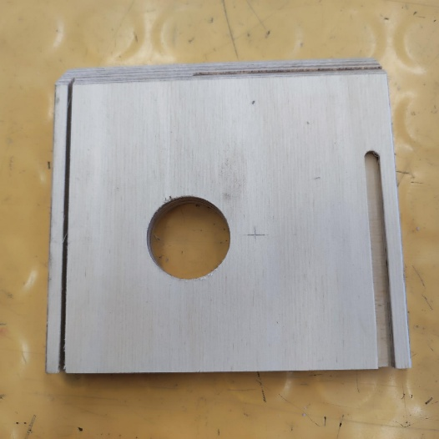

Then start by putting your button inside of it and fixing it in place with the rubber ring:
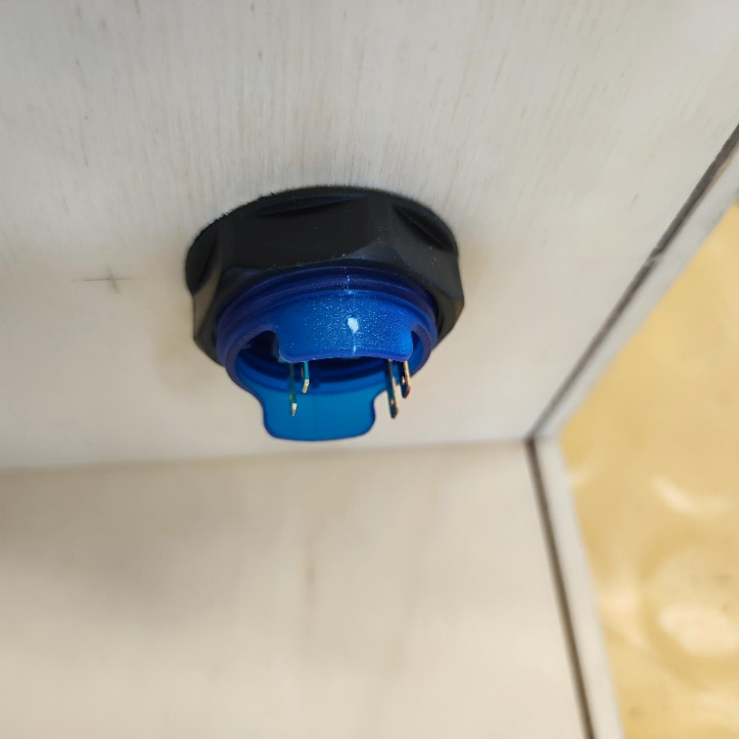
And it should look something like this:
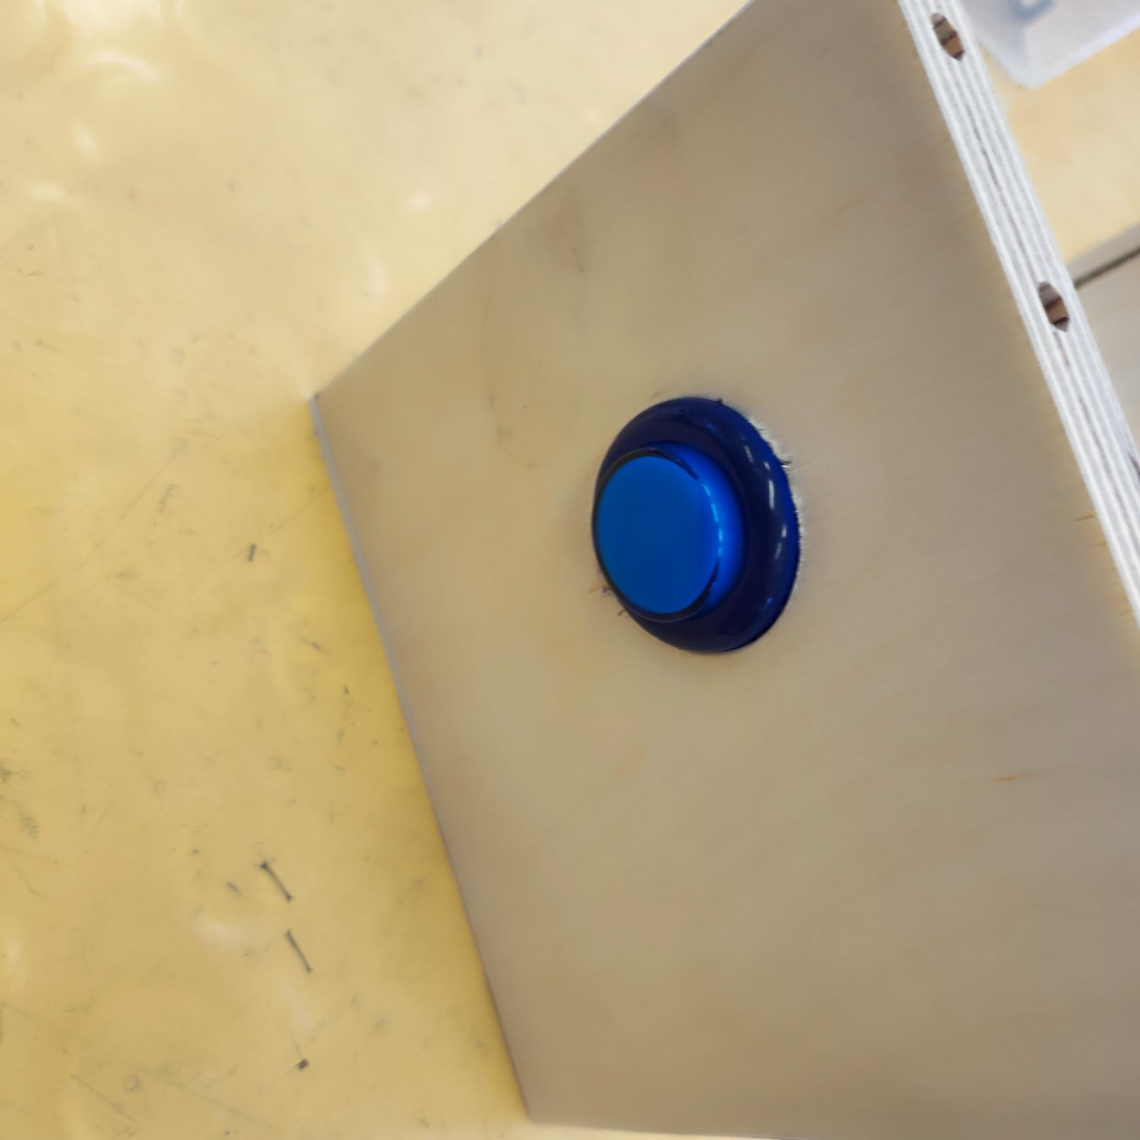

The cables must be soldered to the contacts of this gray sort of “box” like shown below. As it is a button with no polarity it does not matter if the red wire is left or right and vice versa. Only make sure that it is not connected to the 2 other pins:
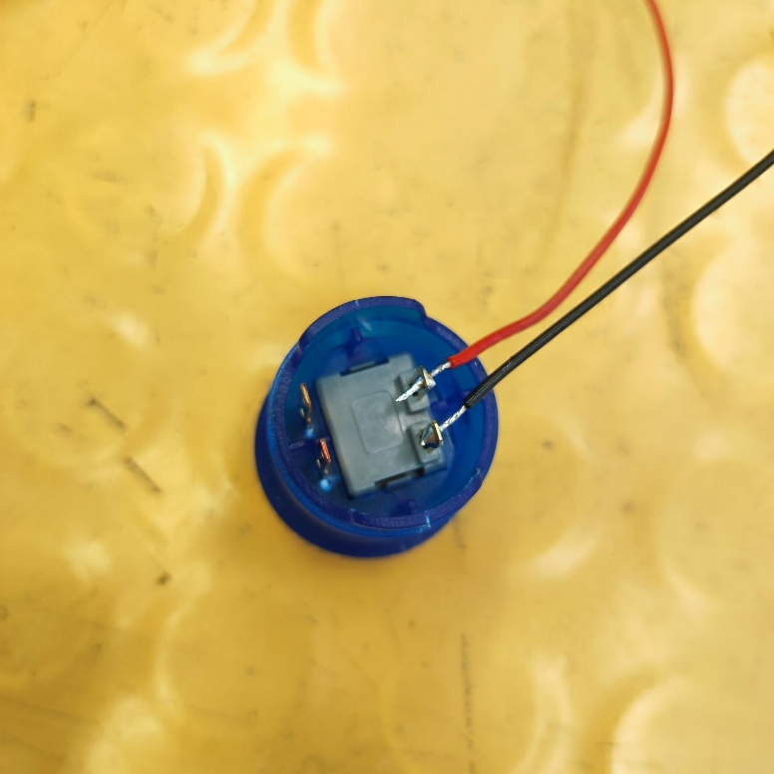

After having it put in place connect both wires to the screw-terminal where it is written SW1 on the PCB. Again the polarity does not matter in this case.
NOTE: This is the black smaller part with the 2 screws on top.
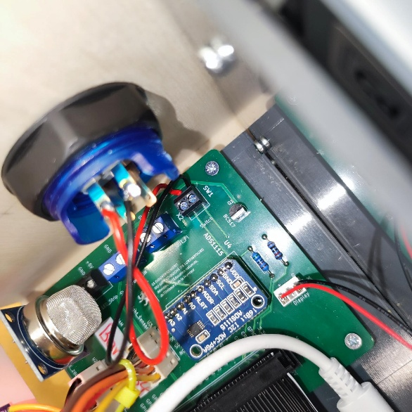

LED strip

Preparing LED strip
Start with 2 pieces of wire (black & red is recommended)
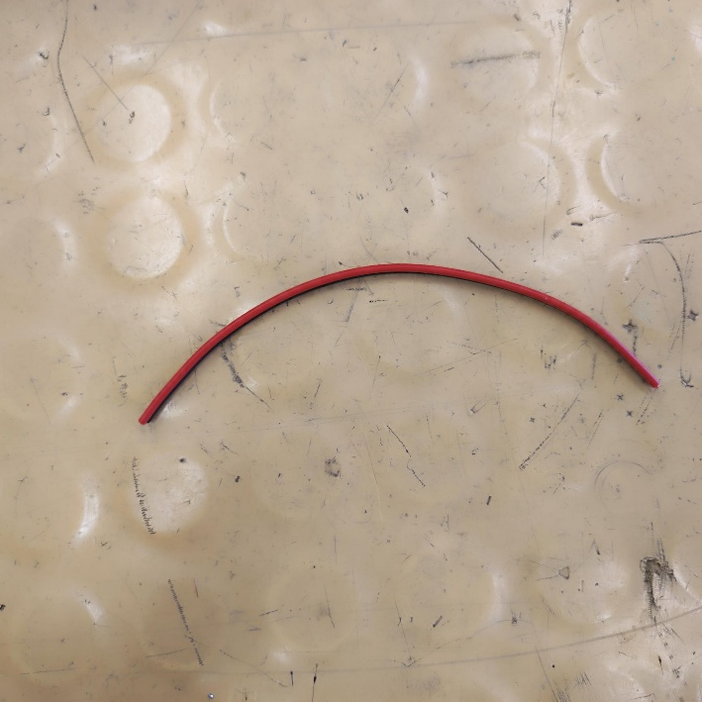
Now take of the insulation with a wire stripper. You could also already apply some solder to each wire to make the connection later on easier like shown below:
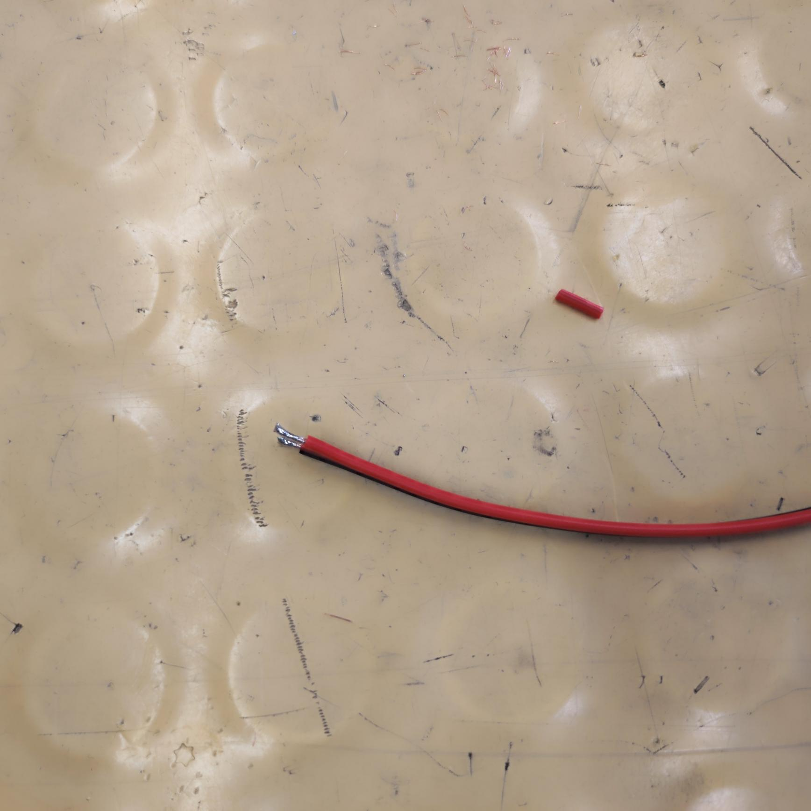

Now it is time to solder both wires to the LED strip. I highly recommend to take the strip a bit of its plastic holder like here before soldering the wires to make your life easier:
Black -> GND
Red -> 5V
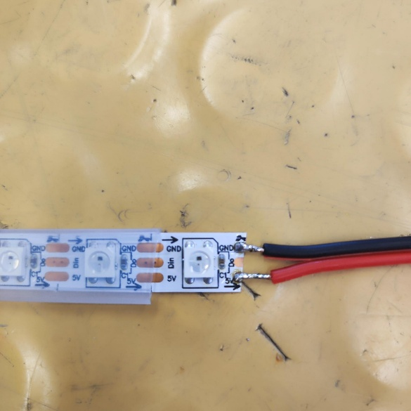
Also do not forget to apply a heatshrink to make a secure connection. A heating gun must be used to shrink the actual tubing:
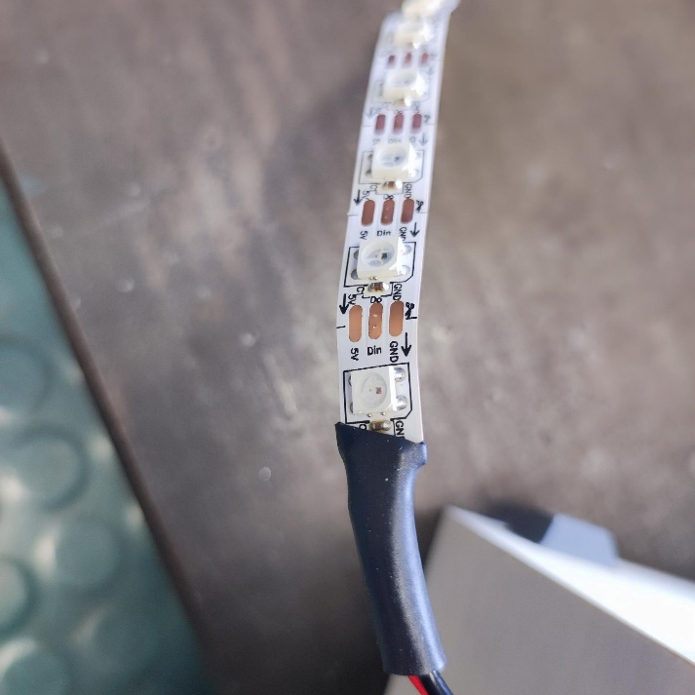

Putting the LED strip in place

Now before putting the strip in place a hole must be drilled on the side where the hole for the button was made in previous sprints. A 3mm should do the job:
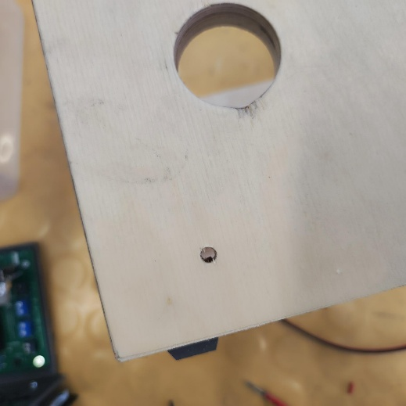
Now let’s glue the actual strip to the front. For that I used a hot glue gun and applied enough glue to it :
NOTE : The plastic cover of the LED strip must be removed otherwise the glue will not hold it properly
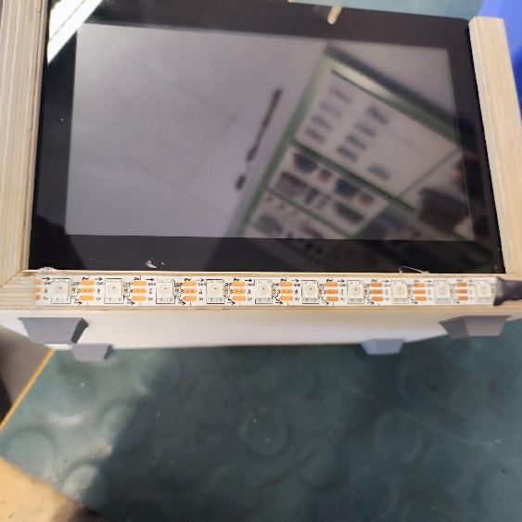

Wire the LED strip to the board
After connecting everything the pin layout is the following:
+5V -> Red wire
GND -> Black wire
